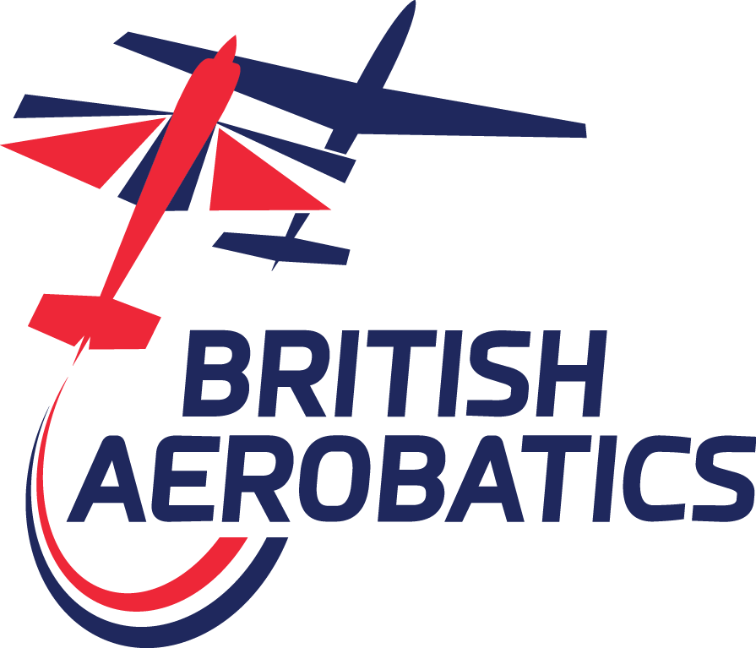
Pilot Proficiency System
Flight Evaluation Process
The following guidelines will be used by British Aerobatics Flight Evaluators (FE) for the initial issue and renewal of Pilot Proficiency endorsements to establish a standardised process for all pilots who request a Flight Evaluation.
Pilots requiring a Flight Evaluation should download this guide and satisfy themselves that they meet the given criteria prior to seeking an appointment with an FE for the endorsement flight, and present the form to the FE with the first section (Applicant’s Personal Details, Qualifications and Experience) duly completed.
1. Documentation:
1.1. The FE should:
1.1.1. Inspect the applicant’s logbook to confirm the pilot's aerobatic experience and currency on the aircraft type that will be used for the demonstration;
1.1.2. Check the applicant's pilot licence and SEP(L) rating, or the equivalent qualification for gliders, British Aerobatics membership and previous proficiency status with the Management Team to ascertain the pilot's eligibility for the evaluation flight;
1.1.3. Check the applicant's aerobatic rating if they have a Part-FCL licence (required for solo competition flight) or Part-SFCL for glider pilots;
1.1.4. Discuss the aircraft's maintenance programme and ask the applicant to warrant that the aircraft is approved for the planned demonstration and is, to the best of their knowledge, free from any defect that might reduce flight safety;
1.1.5. Remind the applicant of the requirement to upload the aircraft's airworthiness and insurance documents to JustGo and ensure these have been approved by the Management Team before competing. Where the pilot will borrow an aircraft from another pilot or a training establishment, they must still confirm these documents have been uploaded to JustGo;
1.1.6. Remind the applicant that the aircraft insurance must state 'British Aerobatic Association Ltd' as an additional insured, not specifically exclude aerobatic contests and must carry a third-party liability insurance meeting the requirements of Article 7 of Regulation (EC) No. 785/2004, or the required Ministry of Defence minimum, if different, when the contest takes place at a Ministry of Defence airfield.
2. Oral Evaluation:
2.1. The FE should:
2.1.1. Discuss the weight, balance and loading limitations; airframe and engine operating limitations; “G” load restrictions and any other operating limitations that are applicable to the demonstration aircraft;
2.1.2. Discuss aerobatic training methods, preparation for aerobatic flights and competition flights. Discuss human performance and its limitations relating to contest flying, including stress, fatigue, dehydration, mental attitude and personal limitations;
2.1.3. Discuss a competing pilot’s responsibilities at a contest, with a focus on good airmanship and safety issues;
2.1.4. Ask the applicant to describe their flight plan - including climb, box entry, safety figures (and any practice/warm-up figures), wing rocks, the aerobatic sequence they intend to demonstrate and the minimum heights they plan to observe. Discuss energy management, planning of manoeuvres in relation to aircraft limitations, the effects of density altitude and the compensation required for differing wind conditions. Include discussion of key heights and speeds and actions to be taken if these are not achieved during a sequence. Discuss the applicant’s approach to planning for and experience of flying Unknown sequences if the applicant has not flown Unknown sequences at contests previously;
2.1.5. Discuss the applicant’s experience of spin training, including recovering from developed forms of all types of spin encountered in the Class of contest flight being assessed. The applicant must warrant that they have conducted appropriate spin training in the aircraft type that will be flown during the evaluation;
2.1.6. Discuss need to position flights within the aerobatic box, avoiding any specified no-fly areas, and discuss the competition minimum height limits for the Class and the need to fly within them;
2.1.7. Discuss eventualities and emergencies planning;
2.2. The FE should determine the applicant’s familiarity and knowledge of:
2.2.1. The General Rules, Operations Manual, Ethical Policies;
2.2.2. For Intermediate (Power) class, Advanced (Glider) and above CIVA Sporting Code Section 6.
3. Preflight Inspection
3.1. The applicant should conduct their normal preflight inspection, with special emphasis on the following areas:
3.1.1. Fuel and oil adequate for the planned flight with contingency reserve as appropriate;
3.1.2. Aircraft structural integrity and freedom of flying surfaces and engine controls;
3.1.3. Thorough check for loose objects in pockets, the cockpit and elsewhere in the aircraft;
3.1.4. Altimeter setting to the proper reference.
4. Flight Demonstration
4.1. The minimum height limit for an endorsement flight must be agreed in advance and must be no lower than that specified in these Rules for the Class of competition concerned.
4.2. For a Power endorsement:
4.2.1. The endorsement flight must be conducted solo by the applicant in a suitable aerobatic box agreed in advance with the FE, who will observe the flight on the ground and be in contact by radio. Where the Applicant is conducting the flight in a multi-seat aircraft and the FE is not familiar with the applicant’s abilities, the FE may want to conduct a dual flight before the solo endorsement flight to satisfy themselves that the applicant will be able to safely handle the aircraft solo and their request for a flight evaluation at this Class is appropriate. The Pilot must demonstrate:
4.2.1.1. For Initial Evaluation An appropriate box entry, safety figures (and any practice/warm-up figures), wing rocks and then the current Fixed Known or a Free Known for the relevant Class. For Advanced (by invitation) and Unlimited only, a proficiency sign-off is required before entering a Freestyle event, for which a Final Freestyle demonstration per CIVA Regulations and successful sign-off must be achieved. Note that Advanced/Unlimited 'Aresti' and 'Freestyle' demonstrations must not be combined in a single flight.
4.2.1.2. For Initial Evaluation The ability to safely fly a selection of additional figures that may be included in Unknown sequences at the relevant Class e.g. for Advanced, canopy up/down tailslides and negative snap rolls from horizontal line. Refer to British Aerobatics General Rules and CIVA Rules for the latest list of Unknown figures.
4.2.1.3. For Renewal Evaluation As for initial evaluation, or, as deemed appropriate by the Flight Evaluator based on their knowledge of the applicant’s experience, a selection of figures that may be included in Known and Unknown sequences at the relevant Class;
4.2.1.4. The ability to recover from the full range of intentional spin types encountered in the Class.
4.3. For a Glider endorsement:
4.3.1. A first flight will be conducted dual with the Flight Evaluator in the aircraft. The assessment follows the same process as described for Power flights.
4.3.2. If the applicant successfully passes the dual assessment, they must then complete a solo flight demonstrating a Known sequence at the relevant class. The Flight Evaluator will observe the flight from the ground and will assess the capability of the pilot using the same criteria described for power assessments.
4.3.3. The applicant must pass both parts of the assessment to be signed off for contest flights at the relevant class.
5. Standards
5.1. To be eligible for endorsement, the pilot must:
5.1.1. Fly the sequence and additional figures (as appropriate for a Power or Glider endorsement) in a safe manner, without contravening height limits (and for Freestyle any designated 'display line') and aircraft limits;
5.1.2. Demonstrate a reasonable degree of skill in positioning the sequence in the prevailing wind conditions;
5.1.3. Demonstrate that they are always in proper control of the aircraft and satisfy the Flight Evaluator that they have sufficient mental capacity to cope with the stress of solo competition flying, especially during Unknown sequences, in the relevant Class.
5.2. Errors of geometry or instances of wrongly executed figures that would give rise to hard zeros in a contest will not be used as reasons for denying the endorsement, provided that the applicant demonstrates appropriate situational awareness and the ability to properly respond to such errors.

6. Reporting And Endorsement
6.1. The Flight Evaluator will conduct a thorough post-flight debrief with the applicant, reviewing any issues that deserve comment.
6.2. The applicant must:
6.2.1 Present the Flight Evaluation form with the first section completed to the FE, who must:
6.2.1.1 Record comments in the Oral Evaluation, Flight Demonstration sections, and overall outcome of the Flight Evaluation (pass or fail) with any relevant comments;
6.2.1.2. Record (along with the Applicant) the Aresti sequence and any additional figures flown with any relevant comments and notes;
6.2.2. Send an electronic copy of the completed form to chairman@aerobatics.org.uk for review and approval. Once approved and returned, upload the approved form to JustGo as an 'Aerobatic Level' credential, which will then be approved on JustGo by a member of the Management Team. An Applicant will only be able to compete at the relevant Class with an approved Flight Evaluation form and corresponding JustGo credential approval.
PILOT PROFICIENCY ENDORSEMENT: INITIAL / RENEWAL (circle as appropriate)
APPLICANT'S PERSONAL DETAILS, QUALIFICATIONS AND EXPERIENCE:
Applicant to complete and sign this section prior to evaluation
Name: ____________________________________________________________________________________
Address: _____________________________________________________ Postcode: ___________________
Email: _______________________________________________________ Telephone: __________________
Pilot’s Licence No: _______________________ Type: ________________ Valid Until: ___________________
Aerobatic Rating (circle): Yes / No Aerobatic Hours Total: ______________ Last 12 months: ______________
Evaluation Aircraft Type: ____________ On Type - Dual Hours: _____________ Solo Hours: _______________
Qualification sought (circle): Club / Sports / Int / Adv / Unl / Freestyle Power / Glider
Applicant’s statement: I confirm the above to be a true record of my details, qualifications and experience
ORAL EVALUATION: Signed: ________________________
Applicant’s knowledge of: Circle Comments (must be filled in)
Documentation / Aircraft Limitations Pass / Fail _________________________________________________
Preparation for Flight / Human Factors Pass / Fail _________________________________________________
Pilot’s Responsibilities at a Contest Pass / Fail _________________________________________________
Sequence Analysis / Planning Pass / Fail _________________________________________________
Spin Awareness Pass / Fail _________________________________________________
Box / Height Minima at this Class Pass / Fail _________________________________________________
Eventualities / Emergencies Pass / Fail _________________________________________________
Rules / Ops Manual / Ethical Policies Pass / Fail _________________________________________________
FLIGHT DEMONSTRATION: Box Location / Airfield: ________________________ on: ____ / ____/ 2026
Pre-Flight Criteria: Max G: _____________ Min G: _____________ Min Ht (ft): __________
Flight Observations: Circle Comments (must be filled in)
Pre-flight Inspection Pass / Fail _______________________________________________________
Climb/Box Entry/Safety Figs Pass / Fail _______________________________________________________
Start/Sequence/Additional Figs Pass / Fail _______________________________________________________
Positioning/Wind Correction Pass / Fail _______________________________________________________
Adherence to Height/Box Limits Pass / Fail _______________________________________________________
Aircraft General Handling Pass / Fail _______________________________________________________
Situational Awareness Pass / Fail _______________________________________________________
Decision: Pass / Fail Comments: ___________________________________________________________
_________________________________________________________________________________________
GLIDER SOLO DEMONSTRATION: Box Location / Airfield: __________________ on: ____ / ____/ 2026
Decision: Pass / Fail Comments: ___________________________________________________________
_________________________________________________________________________________________
ARESTI SEQUENCE & ADDITIONAL FIGURES DEMONSTRATED (include comments/notes)

Flight Evaluator’s statement: I confirm that the applicant has demonstrated:
- Their ability to fly the sequence/any additional figures safely, within height and aircraft limits;
- A reasonable degree of skill in positioning the sequence in the prevailing wind conditions;
- That they are always in proper control of the aircraft and believe that they have sufficient mental capacity to cope with the stress of solo competition flying, especially during Unknown sequences, in the relevant Class.
Evaluator: Name: _____________________ Signed: ____________________ Date: ___ /___/2026
A scanned copy of this completed form, whether a Pass or Fail has been awarded, must be sent to chairman@aerobatics.org.uk as soon as possible by the applicant, and an approved copy will be returned by email. Please then upload the approved copy to JustGo as an 'Aerobatic Level' credential.
(Below to be completed by the Chairman)
Approved by: _________________________ Signed: _____________________ Date: ___ /___/2026

https://www.civanews.com/the-civa-document-store/
https://www.aerobatics.org.uk/publications

