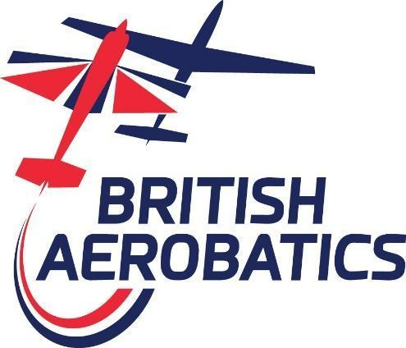

Points Trophy Rules

1.0 Power Points Trophies
Cumulative points trophies are awarded annually, based on pilots’ rank order at contests throughout the season. Points are awarded for each scheduled sequence flown on the basis of 30 points for the best performance, 29 points for the second best and so on.
In any trophy for a specific level, there is a maximum number of sequences that can be counted. This limit is 80% (rounded down to a whole number) of the total number of sequences that take place at that level at British Aerobatics contests in the UK during the year.
Sequences or classes will not be counted if they are flown by only one pilot or where a “cut” has been operated. Scores will not be counted if a competitor is classed as H/C.
A pilot flying more sequences than the countable maximum may discard their worst results until the maximum is reached. In any Trophy open to all levels, the number of points to count will be the lowest number to count at Standard, Intermediate or Advanced that year.
Any tie will be broken by reference to total points scored before discards.

2.0 Glider Points Trophy:
There will be one points table combining results from the Sports, Intermediate, Advanced and Unlimited classes. All scheduled competition sequences will provide scores for all classes.
Sequences where a “cut” has been operated will not be counted.
Special Sequences: All scheduled sequences at the Dan Smith will only provide scores for the Sports class.
The table order will be determined using the percentage arrived at by taking the sum of the actual points scored by a pilot and dividing this by the sum of the maximum points possible for all sequences flown at that level. Any tie will be broken by priority being given to the pilot who flew in the larger class. Where the tie is within a class priority will be given to the pilot with the highest individual percentage score in any sequence. Where the two highest percentages are the same then the next highest percentages are considered until a difference is found.
Pilots flying in more than one class:
The process will be the same in that each score will be assessed against the maximum possible for that sequence. Should such pilots miss a competition then it will be assumed that they would have flown at the level they flew at their previous competition - if the first competition is missed then the level flown at their next competition will be used.
Discards: At present no discards will be allowed. Should the competition program increase significantly in the future then consideration will be given to allowing discards whilst maintaining equality between classes.

3.0 Points Trophies:

Class | Basis of Award | Trophy Name
Sports | Highest points total all sequences flown by power Sports competitors | The Tiger Club Trophy
Sports Unknowns | Highest points total Unknown sequences flown by power Sports competitors | The Marcus Norman Trophy
Intermediate | Highest points total all sequences flown by power Intermediate competitors | The Swinstead Trophy
Advanced | Highest points total all sequences flown by power Advanced competitors | The Manx Kelly Trophy
All classes:
Pitts Aircraft | Highest points total all sequences in any class in any mark of Pitts Special | The Pitts Special Trophy
Cessna 150/152 Aerobat Aircraft | Highest points total all sequences in any aircraft not equipped with an inverted oil system | The Cessna Aerobat Trophy
Yak Aircraft | Highest points total all sequences in any class in a Yak 50/52/54/55 aircraft | The Shaggy Cow Trophy
French-built Aircraft | Highest points total all sequences in any class in a CAP aircraft or derivatives | The Golden Frog Trophy
Extra Aircraft | Highest points total all sequences in any class in an Extra aircraft | The Extra Trophy
Slingsby Aircraft | Highest points total all sequences in SPO or INT in a any mark of Slingsby T67 aircraft | The Slingsby Trophy
Gliders | Highest points total all sequences (see explanation above) | The Glider Trophy

