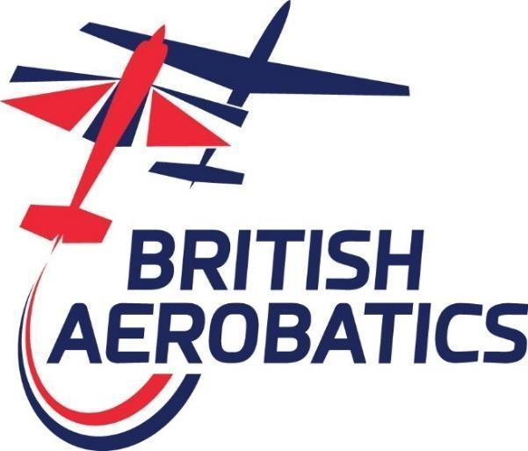

General Rules for the Conduct of Aerobatic Contests & Events

Copyright British Aerobatics © 2026
British Aerobatic Association Ltd, operating as “British Aerobatics”
Registered Office: 22 Portlock Road, Maidenhead, Berkshire. Sl6 6DZ

Total or partial reproduction is forbidden without the written consent of British Aerobatics

Table of Contents
Notable Changes made in this Edition 5
Regulations and Information Resources: 7
1. Safety 8
1.1. Background 8
1.2. Safety Responsibilities 8
2. Airmanship: 9
2.1. Airmanship and Operation of Aircraft 9
3. Officials: 9
3.1. Directors: 9
3.2. Management Team (MT) 9
3.3. Contest Director (CD) 9
3.4. Chief Judge (CJ) 10
3.5. Flight Director (FD) 10
3.6. Contest Jury 10
4. Alignment and Variation from CIVA Rules 10
5. Event Types 10
6. Pilot Qualification 11
6.1. Qualification of Pilots 11
6.2. Proficiency Scheme Sign-off 12
6.3. Fitness Declaration 12
6.4. Foreign Pilots 12
6.5. Nationality with respect to British National Championships 13
6.6. Instructor Qualification 13
7. Aircraft Qualification 13
7.1. Aircraft Requirements 13
7.2. Insurance 14
8. National & Open Championships 14
9. Contest Operation 14
9.1. Contest Entry 14
9.2. Pilot Eligibility 15
9.3. Contest Validity 15
9.4. Practice and Non-contest Aerobatic Flights 15
9.5. Punctuality at Briefings 16
9.6. Late Arrivals 16
9.7. Order of Flight 16
9.8. Timing of Programmes 16
9.9. Airborne Procedures (Powered Aircraft) 16
9.9.1. Box Boundary Demonstration Flight 16
9.9.2. Airborne Hold 17
9.9.3. Radio Procedure 17
9.10. Contest Briefing 18
9.11. Aerobatic Programmes 20
9.11.1. Known Programmes 20
9.11.2. Unknown Programmes 20
9.11.3. Freestyle Programme 21
9.12. Contest Performance Zone 21
9.13. Operation of the Classes 22
9.13.1. Get Into Aeros (GIA) 22
9.13.2. Get Into Aeros Contests (GIAC) 22
9.13.3. Club Class 22
9.13.4. Sports Class 22
9.13.5. Intermediate, Advanced and Unlimited Classes 22
9.14. Height Requirements 23
9.15. Weather Limits 23
9.16. Safety, Warm-up and Practice Manoeuvres 24
9.16.1. Safety Manoeuvres 24
9.16.2. Compulsory Half Rolls: 25
9.16.3. Optional Turns: 25
9.16.4. Optional Brief Push/Pull Loading: 25
9.16.5. 25
9.16.6. Optional Practice Figures: 26
9.17. Wing Rocking/Signalling 26
9.18. Technical Defects 27
9.19. Re-flown sequences: 27
9.20. Use of Smoke: 27
9.21. Exclusion: 27
10. Permitted Unknown Figures 29
10.1. Sports Class (Power) 29
10.2. Intermediate Class (Power) 31
10.3. Advanced Class (Power) 33
10.4. Unlimited Class (Power) 33
11. Judging & Scoring 34
11.1. Judges 34
11.2. Scoring of Contest Programmes 34
11.3. Positioning 34
11.4. Positioning Difficulty Factors 34
11.5. Criteria for Judging the Freestyle Programme 35
11.6. Penalties 36
11.6.1. Application of Penalties 36
11.6.2. Violation of Safety Figure and Optional Figure Procedures 36
11.6.3. Height Penalties 36
11.6.4. Time Penalties 36
11.6.5. Dangerous Flying 36
11.6.6. Break in the Sequence or Insertion of a Figure 36
11.6.7. Violations of Signalling Procedures 37
11.6.8. Directionality 37
11.6.9. Box Out Penalties 37
11.7. Calculation of Overall Scores 37
12. Pilot Proficiency System 38
12.1. Aim 38
12.2. Flight Evaluators 38
12.3. Operation 38
12.4. Evaluation Flights 39
12.5. Standards 39
12.6. Promotion to a Higher Class 39
12.7. Lapsed Proficiency sign-off 39
12.8. Revocation of Proficiency sign-off 40
13. Administrative & Supplementary Rules 40
13.1. Interpretation of Rules and Procedures 40
13.2. Protests 40
13.3. Supplementary Rules and Regulations 40
13.4. Expenses 40
13.5. Membership 41
13.6. Banned or Inappropriate Substances 41
14. Procedure for British Team Selection 42
14.1. Aim and Representation Rights 42
14.2. Performance Evidence 42
14.3. Selection Panel 42
14.4. Pilot Application and Selection. 42
14.5. Other Team Positions 43
14.6. Conduct of Team Members 43
15. Code of Conduct 44
15.1. Background 44
15.2. The Purpose Of Contests 44
15.3. General Principles 44
15.4. The Conduct of Contest Officials 45
15.5. The Conduct of Competing Pilots 46
15.6. The Conduct of Host Airfield Officials 46
15.7. Personal Safety for Pilots 46
15.8. Other Events 47
16. Procedure in the Event of a Serious Accident or Casualty 47
17. Supplementary Rules for Glider Contests 48
17.1. Applicability 48
17.2. Pilot Qualification 48
17.3. Aircraft Qualification 48
17.4. Contest Operation 48
17.5. Airborne Procedures 49
17.6. Height Limitations 49
17.7. Penalties 49
17.8. Sequence Specifications 50
17.9. Permitted Unknown Figures - Glider 51
17.9.1. Sports Class (Glider) 51
17.9.2. Intermediate Class (Glider) 52
17.9.3. Advanced Class (Glider) 54
17.9.4. Unlimited Class (Glider) 54
18. QUICK REFERENCE: POWER 55
Penalties & Positioning 55
Height Limits 55
Weather Limits 55
19. QUICK REFERENCE: GLIDER 56
Penalties & Positioning 56
Height Limits 56

Notable Changes made in this Edition
The 2026 edition contains only minor revisions compared to the 2025 rules.

The most significant changes are:

Rules specify use of Fixed Knowns in contests, with a provision for Free Knowns to be used at an event (e.g. Open contests, glider contests) subject to approval by the Management Team.

Rule 9.9.3.9 now states that “a competitor shall not start a contest sequence unless two-way communication has been established with the CJ”.

Regulations and Information Resources:

General Rules for the Conduct of Aerobatic Contests & Events:
British Aerobatics is responsible for running aerobatic contests in the UK. This publication defines the rules that govern those aerobatic contests. British Aerobatics documents are published at https://www.aerobatics.org.uk/

These rules must be read in conjunction with CIVA Regulations and the British Aerobatics Operations Manual to provide a complete view of how aerobatic contests are operated in the UK.

CIVA Rules:
The sport of aerobatics is governed globally by the Fédération Aéronautique Internationale (FAI) and its Aerobatic Commission (CIVA).

British Aerobatics uses CIVA rules for Intermediate, Advanced and Unlimited classes with some rule modifications and additions deemed appropriate for local operations.

The relevant CIVA Rules are set out in the FAI Sporting Code, particularly Section 6, Part 1 (Power) and Section 6, Part 2 (Glider). CIVA documents are available at https://www.civanews.com/

Operations Manual:
British Aerobatics publishes an Operations Manual that defines the roles that the British Aerobatics Directors, Management Team, Contest Officials and Host Airfield Operator play in planning and executing contests and events.

Aresti System S.L.:
The Aresti System is a catalogue that notates, classifies, names and specifies the difficulty level for aerobatic figures. The catalogue is available from Aresti System S.L. at https://www.arestisystem.com/

Open Aero:
Open Aero provides web based software used to design aerobatic sequences. All sequences used at British contests must be supplied in Open Aero format. https://openaero.net/

Safety

Background
    - The primary consideration at all aerobatic contests/events is the safety of participants and equally that of any members of the public.

    - Article 86 of the Air Navigation Order 2016 deals with civil Flying Displays and special events within the United Kingdom, while CAP 403 details both safety and administrative arrangements for such events. Whilst aerobatic contests, whether part of a Flying Display or not, are specifically exempt from the requirements of Article 86 of the ANO, the rules and procedures implemented by British Aerobatics are intended to create an equivalent or higher standard of safety for all.

    - Where the public has access to the host airfield the officials and participants should comply with those parts of CAP 403 relating to public safety, especially in relation to minimum separation distances between aircraft, in flight and on the ground, and the public.

Safety Responsibilities
    - The British Aerobatic Association Limited (British Aerobatics) places responsibilities on its own officials and the participating pilots to:

      - Uphold the policies, procedures, Code of Conduct and General Rules of British Aerobatics at all British Aerobatics events

      - Ensure that safety always remains paramount

    - The British Aerobatics Operations Manual provides detailed guidelines for all contest officials and co-operating personnel whilst engaged in contest/event related duties.

    - The Chairman of British Aerobatics is ultimately responsible for the safe conduct of all activities undertaken by British Aerobatics. They are responsible for establishing and maintaining all the rules and procedures that might reasonably be expected of British Aerobatics in the furtherance of its aims and objectives.

    - British Aerobatics must be satisfied that a person is fit and competent to act as a contest official, having regard to their previous conduct, experience, and ability to safely execute the office. Contest Directors must ensure that responsibility for aspects of contest/event administration is only delegated to people with relevant experience and, if applicable, licences.

    - A pilot must satisfy British Aerobatics that they are a fit person to participate at an aerobatic contest/event and is qualified by reason of their knowledge, experience, skill and fitness.

    - Where the public has access to a contest/event site the Airfield Operator (or host venue) has the responsibility to ensure public safety at the event and, where appropriate, to comply with those parts of CAP 403 relating to public safety.

Airmanship:

Airmanship and Operation of Aircraft
    - Pilots are always expected to exercise the highest standards of airmanship. Flagrant abuse or disregard of any airmanship requirements may lead to a pilot's exclusion from the event.

    - The pilot in command of the aircraft is responsible for operating the aircraft legally and for observing the Rules of the Air, especially those for avoiding aerial collisions.

    - Pilots must be always mindful of the need to act in a way that protects not only their own safety, but also that of other participants and the public.

    - Special consideration must be given to operating the aircraft in a way that protects public safety during refuelling, start-up, and taxiing.

    - Only the participant shall be on board an aircraft during a scheduled aerobatic flight at a contest. Only the participant and an approved instructor shall be on board an aircraft during Get Into Aeros (GIA) and Get Into Aeros Contests (GIAC) training flights.

    - Pilots must ensure that their aircraft, if powered, carries enough fuel and oil to enable a safe landing to be made after their flight at the host airfield or on a suitable alternate runway, should one runway at the host airfield become unavailable for any reason.

    - The runway(s) shall be kept available as much as possible for emergency landing purposes.

Officials:

Directors:
    - The Board of Directors sets safety policy and provides governance oversight for all British Aerobatics activities.

Management Team (MT)
    - The MT has executive responsibilities for scheduling, management, and oversight of the annual programme of events, including the appointment of suitably experienced Contest Directors, Chief Judges, and other Contest Officials. The MT is responsible for the implementation of the safety rules and procedures. The MT reports to the Board of Directors.

Contest Director (CD)
    - A CD is appointed for each contest. An Event Director (ED) is appointed for other events. The ED performs the same role as a CD as relevant to the event.

    - The CD is responsible for liaison with the host venue and for ensuring that appropriate plans are in place to enable the event to proceed safely and efficiently.

    - The CD is responsible for running the contest from the start of the first briefing on the first day of the contest. The CD exercises overall control in all matters connected with contest administration, organisation and finances for the duration of the event, except for managing the public (including provision of facilities), which is the responsibility of the Airfield Operator.

    - The CD must not take any other part in the contest, except for serving on the Contest Jury.

    - The CD has authority over all other contest officials. At the end of a contest the CD reports a précis of the event to the MT.

    - The CD is responsible to the MT of British Aerobatics for the maintenance of safety at all times during the running of a contest. All personnel, whether contestants or not, are required to act in the safest possible manner during the running of aerobatic contests.

Chief Judge (CJ)
    - The Chief Judge (CJ) is responsible to the CD for the judging of the programmes, and for air safety during any flight directly related to the contest. The CJ has the authority to forbid a pilot to make a contest flight or to continue with a contest sequence for reasons of safety. Chief Judges will be selected by the MT.

Flight Director (FD)
    - The Flight Director is responsible for the efficient and safe marshalling of competing aircraft on the ground in preparation for their timely availability for contest flights.

    - In glider contests, the FD is known as the Launch Point Controller.

Contest Jury
    - The CD, the CJ, and any other persons that the CD may appoint shall, if necessary, form a Contest Jury responsible for deciding all protests, disciplinary matters, exclusions, disqualifications, and any other matters related to the running of the contest.

    - The CD shall chair and speak for the Contest Jury, whose decision in all matters shall be final.

Alignment and Variation from CIVA Rules
    - The intent is to align these British Aerobatics General Rules with CIVA Rules principally for matters concerning definition of aerobatic programmes (sequence specifications and figure versatility) and judging criteria, subject to specific variations described in this document. Operation of British Aerobatics contests may vary from CIVA Rules as described by these General Rules and in the Operations Manual. The CD and CJ will interpret how to implement rules at each contest or event.

Event Types
    - British Aerobatics is responsible for running two main activities: training events and contests.

    - Get Into Aeros (GIA) and Get Into Aeros Contests (GIAC) are powered training events. GIA provides an introduction to aerobatics to pilots who have not flown aerobatics previously. GIAC provides an introduction to aerobatic contests for pilots who hold aerobatic privileges.

    - Contests involve competition between pilots flying aerobatic sequences in front of a panel of judges who assess the accuracy of each flight to determine rank order of performance. Contests operate at five proficiency classes: Club, Sports, Intermediate, Advanced and Unlimited.

    - The MT may sanction other events of a specialist nature, for example, classic aircraft, or One-Design contests. In these cases, additional rules will be published by British Aerobatics to ensure safe and proper conduct of the event.

Pilot Qualification

Qualification of Pilots
    - All UK pilots who participate at British Aerobatics events or contests must hold a valid, current UK Private Pilot Licence (PPL), NPPL, or Light Aircraft Pilot Licence (LAPL) and must comply with any restrictions placed on the licence by the accompanying medical certificate.

    - All pilots must be a current Member of British Aerobatics.

    - A valid, current pilots licence (as described in the first paragraph above) and current membership of British Aerobatics qualifies pilots to enter a Get Into Aeros (GIA) event.

    - Pilots participating at Get Into Aeros Contests (GIAC) events or British Aerobatics contests must also hold aerobatic privileges. If a pilot holds a licence that permits aerobatic flight without holding an aerobatic rating, they must have completed a CAA approved basic aerobatic training course or must show evidence of appropriate aerobatic experience to the Chairman of British Aerobatics and will be given a ‘qualification by experience’ exemption.

    - All participants at Get Into Aeros (GIA) or Get Into Aeros Contests (GIAC) will fly with an approved instructor.

    - Pilots participating at contests or specialist events must also fulfil the following requirements:

      - All competitors flying at Club, Sports, Intermediate, Advanced or Unlimited classes at a contest must fly solo.

      - To enter a competition or event solo a pilot must hold a licence that permits solo aerobatic flight in the aircraft to be used at the contest/event.

      - All pilots must provide contact details (telephone and postal address) for the person or persons to be notified in the event of accident, sickness, or injury.

Proficiency Scheme Sign-off
    - All pilots competing solo at any event or contest must hold a British Aerobatics proficiency sign-off endorsed for the appropriate class by a Flight Evaluator approved by British Aerobatics or hold a ‘qualification by experience’ endorsement from the Chairman. The Flight Evaluator must be a current member of British Aerobatics at the time of the sign-off.

    - Any pilot who has not competed in a British Aerobatics contest at the appropriate class within the last 24 months must gain a further proficiency sign-off prior to entering a contest.

    - All competitors entering a Freestyle contest will require Freestyle Flight Evaluation signoff or ‘qualification by experience’ endorsement from the Chairman.

    - Appropriately qualified Advanced level pilots may on occasion be invited to participate in a Freestyle contest. They must successfully complete a Flight Evaluation assessment (following the Unlimited Freestyle Assessment procedure) conducted by a British Aerobatics Flight Evaluator or hold a ‘qualification by experience’ endorsement from the Chairman.

Fitness Declaration
    - During the the Main Briefing and each Safety Briefing, the CD will state that each competitor/participant is required to be:

    - Fit for flight
    - In current practice at the class of contest entered
    - Certain that the aircraft to be used is serviceable and certified for the intended aerobatic sequences.
    - Aware of the anti-doping rules and procedures. Competitor/participant agrees that they are in compliance with the anti-doping requirements and competitors responsibilities

    - If a competitor/participant cannot fulfil all of these requirements, they are not eligible to participate and should withdraw from the competition. Participation in the contest shall be evidence that each competitor/participant accepted and declared they fulfilled these requirements.

Foreign Pilots
    - A foreign pilot is a pilot not holding a valid UK passport or UK residency (permanent right to remain).

    - Foreign pilots may compete/participate in British Aerobatics contests/events subject to their holding a valid pilot's licence issued by an authority recognized by the UK CAA and valid for use in the UK. They must also comply with any restrictions placed on the accompanying medical certificate, which must be current. They must be a current member of British Aerobatics. It is the responsibility of the pilot to ensure they and the aircraft they intend to fly has appropriate licensing and certification required by the UK CAA for aerobatic solo flight.

    - Foreign pilots must show evidence of their aerobatic skill level issued by an aerobatic governing body from their state of residence or nationality or, for Intermediate, Advanced or Unlimited pilots, a record of achievement of safe participation at a domestic National Championship, an Open Contest, or World, Continental or European FAI Championship within the previous 24 months. Failing this, they shall be required to either complete the appropriate Flight Evaluation with a British Aerobatics Flight Evaluator or or request a ‘qualification by experience’ endorsement from the Chairman.

Nationality with respect to British National Championships
    - The title "British National Champion" and its corresponding trophy will always be awarded to the highest-placed pilot who has a valid UK passport or UK residency (permanent right to remain), and has not chosen to represent, been selected to represent, or has represented another country at FAI International contests within the past 4 years.

Instructor Qualification
    - Instructors at GIA and GIAC events must be approved by British Aerobatics. The instructor shall be Pilot in Command.

    - The instructor must have FIying Instructor (FI) or Class Rating Instructor (CRI) ratings with aerobatic privileges, must be a current member of British Aerobatics and must hold a current proficiency sign-off endorsed at Intermediate class or higher, unless otherwise approved by the Chairman. The Directors and Management Team will maintain a list of approved instructors.

    - The instructor shall not be a competitor or act in any official capacity at the same event or contest.

Aircraft Qualification

Aircraft Requirements
    - Piston, turbine or electric power plant (single or twin) aircraft or gliders under 12,500 lbs (5,700 kg) MTOW may compete. Pilots flying powered aircraft in Glider contests must stop their engines in level flight at tugging speed before starting their sequence.

    - All aircraft must have a valid Certificate of Airworthiness, Permit to Fly, or an equivalent document issued by a competent authority and must be approved for aerobatic flight.

    - Aircraft registered outside of the UK must comply with all the CAA’s certification requirements for the purpose of participating at an aerobatic contest/event in the UK, or be exempted therefrom by the CAA in writing.

    - All aircraft should employ a duplex harness or a single harness and pilot’s parachute.

    - All aircraft must be equipped with a properly functioning air-band transceiver radio able to communicate on 8.33kHz VHF channels.

    - Aircraft equipped with a transponder should squawk 7004 during aerobatic flights.

    - In case of doubt over its serviceability, or in the event of a defect occurring that requires immediate rectification, the CD may require an aircraft to undergo a technical inspection by a suitably qualified technician.

Insurance
    - All aircraft must carry a third-party liability insurance meeting the requirements of Article 7 of Regulation (EC) No. 785/2004, or the required Ministry of Defence minimum, if different, when the contest/event takes place at a Ministry of Defence airfield.

    - The insurance cover must clearly state that the British Aerobatic Association Limited is noted as an additional insured and that the insurance does not exclude aerobatic contests.

National & Open Championships
    - At least two sequences must be flown, to determine the British National Champion at any class.

Contest Operation

Contest Entry
    - The contest/event entry deadline will be published on the contest administration web platform. Entries will not be accepted after the closing date, other than in very exceptional circumstances subject to approval by the MT.

    - By entering a contest/event, the participant agrees to be bound by all the General Rules of British Aerobatics and the British Aerobatics Code of Conduct.

    - British Aerobatics will determine and publish entry fees for each contest/event.

    - All documents relating to licensing (pilot and aircraft), insurance and currency must be uploaded to the contest administration web platform by the entry deadline. Participants can enter a contest/event if they do not yet have all of these documents available, but must ensure that all documents are valid, current and uploaded no later than the entry deadline, except that Flight Evaluation documents for glider pilots can be uploaded the day before the contest starts subject to approval by the CD. The validity of these documents will be checked by either the MT or the relevant contest CD.

    - A participant shall be refused entry by the CD/MT if the pilot or aircraft do not satisfy the conditions of entry for the contest/event, or on grounds of safety, or on any other reasonable grounds.

    - The entry fee of a participant whose entry is refused shall be refunded.

    - The entry fee of a participant who withdraws from a contest/event at any time prior to the closing date for entries will be refunded.

    - A participant who has paid in advance but who withdraws after the closing date or is otherwise unable to enter the contest/event will forfeit their entry fee.

    - Entry fees will not be refunded if bad weather results in a contest being cancelled or shortened. The MT will decide if fees should be refunded for cancellations made in other circumstances.

Pilot Eligibility
    - A pilot who has competed at higher classes of competition within the past 12 months and wishes to drop to a lower class may only do so if they have not placed first, second or third in the higher class in the current or previous contest season.

    - The pilot may only drop one class level.

    - Notwithstanding the restrictions described above, any pilot may enter any contest Hors Concours in a lower class. (Hors Concours means that results from a pilot will not count towards the designation of official placings or award of medals). The MT may approve dropping by more than one class or within a shorter period of time in exceptional circumstances. The pilot should make appropriate representations to a member of the MT.

Contest Validity
    - A valid contest requires a minimum of two entrants, except for National Championships which normally require a minimum of 3 entrants before the National Title and trophy are awarded. In circumstances where only 2 entrants have registered for a National Championship, the MT will decide if this constitutes a valid contest as soon as possible after the closing date for entries.

    - Gold, silver and bronze awards will normally be made even if there are only 2 or 3 contestants in a particular class but may be withheld at the CD’s discretion if the pilot’s performance is less than 60% of possible marks.

Practice and Non-contest Aerobatic Flights
    - Practice flights at or within 10 nm of a powered contest site in the 7 days before the contest are generally discouraged to avoid noise nuisance to neighbours. At certain events practice days may be designated before the contest. Such practice days will be overseen by the CD and will accord with British Aerobatics contest operating procedures and rules.

    - Non-contest aerobatic flights at the contest site during the contest require prior authorisation by the CD.

    - Any practice flights departing from the contest airfield on contest days, must be to locations agreed with the Airfield Operator and the CD.

    - No practice flights will be permitted for a competitor after the first contest flight at the competitor’s class has taken off or if an Unknown program has been published at that class.

Punctuality at Briefings
    - The CD will gather available participants and officials at the original briefing time published by British Aerobatics and will carry out a roll call.

    - If the weather is expected to meet contest minima in one hour or less, or if all the participants are present, the Main Briefing will be given in full. If neither of these criteria is met, the CD will declare an appropriately delayed briefing time, based on the forecast weather conditions.

    - At the rearranged time, the CD will again review the weather forecast and carry out a further roll call. They will give the Main Briefing at this new time should either of the above criteria be met. Continued bad weather should lead to further delays in the briefing time until and unless an alternate solution becomes necessary.

Late Arrivals
    - A participant who is not present at the Main Briefing will not usually be permitted to fly in the contest/event. In exceptional circumstances, the CD will permit a participant to fly, subject to the:

    - agreement of all pilots competing at that class
    - participant arriving before the first flight at that class commences
    - CD having time available to provide the participant with a briefing

    - In all matters of judgment regarding Late Arrivals, the CD’s decision shall be final.

Order of Flight
    - The order of flying for a programme will normally be determined by the drawing of lots or by randomised computer selection.

    - The resultant order of flying may be altered by the CD if the multiple usage of aircraft will cause delays in the completion of the programme.

Timing of Programmes
    - Programmes will be timed as required by CIVA Rules.

Airborne Procedures (Powered Aircraft)

Box Boundary Demonstration Flight
      - The CJ may ask one or more pilots to demonstrate minimum and disqualification heights and the box boundaries by flying appropriate lines at designated heights through the box. The CJ will brief the pilot on how this flight should be conducted. Box boundary demonstration can be conducted by a competing pilot at the start of a competition flight. In this case timing of the programme will begin once the box boundary demonstration has been completed.

Airborne Hold
      - The CD may require contestants to maintain an airborne holding pattern. In this event, a hold area will be designated at a safe distance from the performance zone and clear of restricted or sensitive areas. Pilots must arrange their take-off time so that they are in the airborne hold at their starting height before the preceding contestant has completed their sequence. At all times, the pilot must ensure their aircraft stays within sight of the judging position and clear of other aircraft and the performance zone.

Radio Procedure
      - Pilots should make the usual radio calls on the airfield frequency until airborne.

      - Notwithstanding any radio calls exchanged with a ground station, the responsibility for seeing and avoiding other air traffic rests entirely with the pilot at all times.

      - No pilot should take off until they are sure that the hold, if in operation, will have been vacated by the time they reach it.

      - Once airborne, the pilot should call on the airfield frequency that they are switching to the safety frequency.

      - The safety frequency is a declared “silent frequency” used by the CJ or nominated representative to communicate with the competing pilot. All exchanges are normally initiated by the CJ. The pilot should thus listen-out until invited by the CJ to enter the performance zone.

      - The pilot should listen for the preceding contestant to call “(callsign) – box vacated” as a clear indication that a call from the CJ inviting entry to the box may be expected.

      - Should the pilot experience an unusual delay indicating that circumstances may have led to the CJ being unaware of their presence at the hold point then, after visually determining that the preceding pilot has in fact departed the box en-route to joining the circuit, the pilot may make a brief call to check the CJ’s awareness of the situation – for example: “Chief Judge (callsign) is waiting in the hold”.

      - On receipt of a call from the CJ to confirm that the box may be entered at the pilot’s discretion. It is always the pilot’s responsibility to ensure that the box is clear and it is safe to enter the box. The pilot must reply to confirm that the message has been received and understood.

      - Unless and until this two-way communication has been established the pilot must remain clear of the performance zone. A competitor shall not start a contest sequence unless two-way communication has been established with the CJ. Failure to comply with this rule may lead to exclusion from the programme or from the contest.

      - The CJ (or CD) may transmit calls of the following three types during a competition flight in the box:

“Box, box, box”
indicates that the CJ believes that safety is compromised because the competitor is flying outside of the designated performance zone and should reposition within the box before continuing with the contest flight, by taking a break if necessary. The break will be recorded as a penalised break. If a pilot ignores the “Box, box, box” call and fails to reposition promptly, the CJ may instruct the pilot to land without completing the sequence. In these circumstances a re-flight will not be permitted.

“Break, break, break”
indicates that the CJ requires the pilot to interrupt their sequence immediately, attain level flight and then discuss the situation with the CJ before resuming the sequence. The CJ will decide if this break should be penalised in consultation with the CD.

“Land, land, land”
indicates that the CJ requires the pilot to cease flying the sequence immediately and expedite landing. The CJ will explain the circumstances to the pilot as required by the situation. The CJ will decide if this break should be penalised in consultation with the CD.

      - It is not necessary for pilots to make RT calls regarding mid-sequence breaks, wing-rocks, re-entering the box etc. Such transmissions are acceptable but may receive no acknowledgement.

      - Upon completion of the sequence the pilot should call “(callsign) - box vacated”, before changing to the airfield frequency and resuming normal radio procedures.

      - If an airborne aircraft has a radio failure before being called into the box, the pilot should land in accordance with standard non-radio procedures and immediately report to the CD. In the event of a radio failure during or after the sequence, the pilot should complete their flight, land in accordance with standard non-radio procedures and immediately report to the CD. The CD will decide the appropriate course of action in both situations described. The aircraft must have a serviceable radio before flying again at the contest.

      - The unauthorised use of radio or any other communication device for the purpose of communication with a ground observer in connection with the contest programme will result in exclusion from the contest.

Contest Briefing
    - The CD and CJ shall conduct a Main Briefing for all pilots not less than one hour before the start of contest flying.

    - At briefing a roll call will be recorded to establish those present.

    - The Main Briefing shall cover:
- Introduction of the contest and host airfield officials;
- The importance of maintaining safety of competitors, participants and third parties as the primary concern. Key pilot responsibilities for maintaining safety:
  - confining aerobatic sequences to the performance zone;
  - observing the appropriate height minima;
  - observing the British Aerobatics Rules (CIVA Rules where relevant for Intermediate, Advanced and Unlimited), the Code of Conduct and the Air Navigation Order/Rules of the Air Regulations;
- Fitness Declaration, which will be read out at each briefing:
  - All competitors are required to be:
    - fit for flight
    - in current practice at the class of contest entered and holding required pilot licencing for solo aerobatics
    - certain that the aircraft to be used is serviceable and certified for the intended aerobatic sequences
    - aware of the anti-doping rules and procedures and complying with the requirements and competitors responsibilities
- Weather forecast and method for determining weather limits
- Description and location of the aerobatic performance zone:
  - contest axis
  - emergency landing area(s)
  - no fly zone(s), including public car parks
- A detailed drawing to show the location of the performance zone; crowd and display lines must be shown if in use at the contest
- Start-up, taxi, take-off and airborne holding procedures
- Safety frequency and its use
- Safety rules and minimum heights
- Selection of figures for Unknown programmes if required
- Sufficient review of any matters connected with the contest to ensure a complete understanding by all
- The method to be used to determine the order of flying for each programme and class; any hors concours competitors must be identified and the CD will describe how H/C flights will be incorporated into the flying order
- Time check and target time for first flight

    - An order of flights shall be published as soon as possible after the briefing.

    - The following items can be promulgated using a written briefing issued prior to the start of the contest, or can be covered in the Main Briefing at the discretion of the CD and CJ.
    - Description of the airfield facilities and operating regulations, including local airspace restrictions, and any facility fee payable per aircraft to the host airfield operator;
    - Description of the initial Emergency Response planned for the event. The names of the Deputy CD and Public Relations Officer where these have been so designated;
    - Location and contact details for emergency diversion airfield(s).
    - Any special procedures for flying the aerobatic programmes, including clarification of judging criteria if required;
    - Clarifying the contest timetable;
    - The judging criteria applicable to the programmes to be flown.

    - There will be a Safety Briefing on each subsequent day of a multi-day event, covering essential safety, weather, operational and contest information.

Aerobatic Programmes

Known Programmes
      - A Fixed Known (sequence designed by British Aerobatics) will be used at all classes unless the Management Team approves use of a Free Unknown for a specific contest (for example the UK Open or a glider contest).

      - If Free Known sequences are used they will be designed according to CIVA criteria. Compulsory Figures required to build Free Known sequences and Default Free Known sequences will be published by CIVA at the beginning of each year.

      - British Aerobatics will publish a Default Free Known sequence to be used by competitors who do not submit a Free Known sequence before the contest entry deadline.

Unknown Programmes
      - Unknown programmes may be given in Sports and higher classes. Fixed Unknown sequences will be used at all contests.

      - Unknown sequences for Sports class will be designed according to British Aerobatics rules.

      - Unknown sequences for Intermediate, Advanced and Unlimited classes will be designed according to CIVA criteria for figure specification, versatility requirements and difficulty limits (K factors), subject to modifications described in these rules, such as use of Fixed sequences (all pilots fly the same sequence) and expanded figure repertoires for Intermediate and Advanced classes as defined in the Permitted Unknown Figures section of these rules.

      - Unknown sequences will usually be prepared by the British Aerobatics Sequence Design Team. These sequences will be prepared ahead of each contest and will not have input from competitors.

      - On occasion, sequences will be built using figures nominated by competitors at an event as described in CIVA Rules. Should fewer than 10 competitors be participating at a particular class, the CJ in consultation with other British Aerobatics officials may submit unknown figures to bring the total number of nominated figures to 10. Regardless of how Unknown figures are selected, the resulting versatility shall not be less, nor the number of flick rolls more, than that specified by the CIVA criteria.

      - Competitors may be asked to submit sequence proposals. British Aerobatics will also design a sequence. The CD and CJ in consultation with other British Aerobatics officials will select the most appropriate sequence. The CD may poll competitors to get their view on the most appropriate sequence.

Freestyle Programme
      - A Freestyle Programme may be included in the power Unlimited Class.

      - The Freestyle programme will be treated as a separate contest. Judging criteria and method for calculating scores for the Freestyle programme will be based on British Aerobatic rules.

      - Time limits for specific Freestyle Programmes will be published on the relevant contest listing published on the contest admistration web platform.

Contest Performance Zone
    - The performance zone (the “box”) is the area where all contest sequences will be flown. The performance zone is designated by the CD and CJ, in consultation with the Airfield Operator and the MT.

    - A Director and the Chairman shall approve the designated performance zone and the associated Risk Analysis in advance of each event as described in the Operations Manual.

    - The box location will be published on the contest administration web platform or British Aerobatics website no later than the closing date for entry to the contest.

    - All competitors will be expected, to the best of their ability, to fly the programme within the limits of the Performance Zone. A suitably qualified pilot will delineate the axes and height limits of the zone to the judges prior to commencement of judging. If at any stage the CD or CJ suspects that a contest pilot is at immediate risk of flying over a congested or public area outside the 'box', they shall take immediate steps to try to prevent any unsafe situation arising using the appropriate radio procedures.

Operation of the Classes

Get Into Aeros (GIA)
      - Get Into Aeros is an event that gives pilots who are new to aerobatics a chance to learn about the sport and to experience flying aerobatics with a qualified instructor. It is not a competition.

Get Into Aeros Contests (GIAC)
      - Get Into Aeros Contests is an event that gives pilots who hold aerobatic privileges an opportunity to learn more about competition aerobatics.

      - Operation of GIA and GIAC events is described in the Operations Manual.

Club Class
      - The Club Class is an entry level competition.

      - Contestants fly the Club Fixed Known program. Pilots may be given the opportunity to fly the sequence multiple times at some contests.

      - The primary concern during any Club flight is safety, and the minimum height rule is paramount. There are no penalties for breaks to reposition, gain height etc, nor will such instances be subject to a downgrading of the score for positioning.

Sports Class
      - Contestants will be required to fly the Fixed Known which will contain a minimum of 6 and a maximum of 10 figures, with aggregate K between 100 and 125.

      - Contests may also be required to fly one or more Unknown Programmes, containing a minimum of 6 and a maximum of 10 figures chosen from the list of permitted unknown figures.

Intermediate, Advanced and Unlimited Classes
      - Intermediate, Advanced and Unlimited Classes will be run according to CIVA Rules, subject to variations described within these rules, within the Operations Manual or as deemed necessary by the CD or CJ at a particular event. Any rules or operational variations implemented by the CD or CJ will be noted in the Main Briefing.

      - Contestants will be required to fly a Fixed Known Programme, unless the Management Team approves use of a Free Known for a specific event.

      - Free Known sequences, if required, must be submitted as a Credential on JustGo no later than the contest entry deadline.

      - All sequences must be submitted as an OpenAero .seq file.

      - The competitor should use Open Aero to check legality of the sequences before submission. Sequences and files must be clearly labelled with the contestant’s name and contest.

      - Contestants may be required to fly one or more Fixed Unknown Programmes.

Height Requirements
    - Flying aerobatic sequences at an appropriate height is a critical safety measure.

    - Minimum heights are specified for all flights.

    - Any pilot contravening these minimum safety heights will be liable to disqualification from the programme concerned or from the event. The decision to disqualify a pilot will be made by the CJ in consultation with the CD. The decision of the CD will be final.

 | Club | Sports | Intermediate | Advanced | Unlimited
Upper | None | None | None 3 | None 3 | None 3
Lower | 1500 ft | 1000 ft | 1000 ft 1 | 660 ft | 500 ft 2
Exclusion | 1300 ft | 800 ft | 800 ft 1 | 500 ft 2 | 500 ft 2
Height limitations are taken from CIVA Sporting Code Section 6-1 except as modified by:
1 Intermediate class heights for British Contests are set higher than CIVA rules
2 Flight below 150m (500 ft) can only be allowed with an exemption from the CAA to the low flying regulations SERA.5005 (f)
3 Upper height limits will not be enforced at British contests

All heights are Above Ground Level
    - Training flights at Get into Aeros (GIA) and Get Into Aeros Contests (GIAC) events will be completed at a safe height consistent with Best Practice for training flights away from the airfield and will not involve ‘box’ flights.

    - Upper height restrictions may be imposed if local airspace rules do not permit upper limits to be unrestricted in Club, Sports, and Intermediate classes. In such cases, un-penalised breaks at specific points shall be allowed for safety reasons.

    - The lower height limitations may be increased by the CD if deemed necessary by local operating conditions or obstructions within or adjacent to the performance zone (‘box’).

Weather Limits
    - The CD will permit contest flights only when the local weather conditions meet, or are better than the minima described in the table below.

 | Cloudbase and visibility MINIMA below which no flying will happen
 | Club | Sports | Intermediate | Advanced | Unlimited
Min Cloudbase | 3000 ft | 3000 ft | 3000 ft | 3000 ft | 3000 ft
Min Visibility at 3000 ft | 5km | 5km | 5km | 5km | 5km
All heights are above ground level
    - If cloudbase, headwind or crosswind conditions reach the Free Break limits (see table below) the CJ will permit the contestant to interrupt their programme once to regain height without incurring any penalty, so long as the aircraft is flying in the correct attitude and direction as required by the sequence diagram when the break is taken.

 | FREE BREAK weather limits
 | Club | Sports | Intermediate | Advanced | Unlimited
Cloudbase | any number of unpenalised breaks may be taken at the pilot's discretion |  | 4100 ft | 3800 ft | 3500 ft
Headwind |  |  | > 24 kts | > 24 kts | > 24 kts
Crosswind |  |  | > 16 kts | > 16 kts | > 16 kts

    - Measurement of weather conditions shall be by direct observation by suitably experienced contest participants, by appropriate instrumentation installed at the host airfield or by current actual reports available from the Meteorological Office Aviation service or equivalent.

    - The scheduling, suspension or postponement of contest flying and any change to the contest axis and/or direction of flight to meet prevailing weather conditions shall be at the discretion of the CD in consultation with the CJ. When such changes are made, the next competing pilot must be allowed a minimum of 30 minutes preparation time before flying resumes.

    - No flying will be permitted when there is known electrical storm activity within 5 nm of the host airfield.

    - By accepting the opportunity to fly, a contestant implicitly confirms that they have sufficient training and experience to fly the planned sequence safely in the prevailing conditions.

    - At any time prior to or during the sequence flight, if a contestant considers that the weather has deteriorated to a point where they will be unable to complete the programme in safety or within the rules, they may abort their flight.

    - Upon landing they should report their reasons to the CD. The CD and the CJ will review the contestant's reasons, and if they consider them valid then the programme may be re-flown if conditions improve. Otherwise, a weather check flight will be made within 15 minutes, after which, if the reasons are not considered valid, the programme will not be re-flown, and the contestant will only be marked on the part that was completed.

Safety, Warm-up and Practice Manoeuvres

Safety Manoeuvres
      - All pilots shall perform safety manoeuvres before the wing-rocking at the start of the judged section of each contest flight in all Programmes.

Compulsory Half Rolls:
      - All pilots in all categories shall perform at least two half rolls with a stop at the inverted position. The half rolls (1.1.1.3 & 9.1.3.2 and 1.1.1.4 & 9.1.3.2) must be flown before any practice figures:
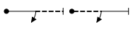
These figures are flown to check the aircraft’s inverted fuel and oil systems are operable, there are no loose articles in the aircraft and to ensure that the pilot is properly harnessed in.

Optional Turns:
      - Pilots may perform any number of turns (erect or inverted, but not rolling turns) as warm up manoeuvres, separately or in one continuous turn. These warm-up manoeuvres are flown to help prepare the pilot for the upcoming g-loadings and to help reduce the risk of g-loc.

Optional Brief Push/Pull Loading:
      - As additional safety checks, pilots may perform push/pull stick inputs (in any order and number, in erect or inverted flight). These warm-up manoeuvres are flown to create instant g-loading and hence an additional check of the harness and absence of loose articles in the aircraft.

Optional Practice Figures:
      - Pilots may also fly the following optional practice figures.

Sports & Intermediate | Advanced & Unlimited
One or both of:  a) Stall turn (5.2.1.1) without rotations  b) Humpty Bump (8.4.1.1) without rotations | Up to three figures selected from the following:  a) 2-line stall turns (all figures in Family 5.2.1) without rotations  b) Humpty bumps starting vertical up (all figures in Family 8.4 rows 1 to 4, columns 1 and 2) without rotations  c) Horizontal 8’s as follows: 7.8.4.1 with two half rolls only; 7.8.1.1 without rotation:  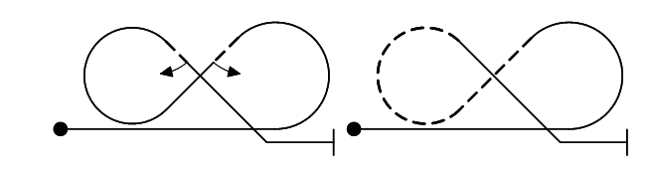
Free Known Programme Only (subject to approval by the CD contest by contest)

Each pilot may practice, consecutively, up to the first 5 figures of their Free Known sequence in addition to and after the safety, warm-up and practice manoeuvres/figures described previously
These optional figures provide additional preparation for g-loadings and allow the pilot to assess the wind direction and drift in the performance zone. They may be flown only once, in any order.
      - All Safety, Warm-up and Practice manoeuvres/figures must be flown inside the performance zone above the minimum height for the class. Any low flying observed will be penalised as though it were in the judged sequence.

      - All Safety, Warm up and Practice manoeuvres/figures as well as the full aerobatic sequence must be completed within the time allowance for the Programme being flown.

Wing Rocking/Signalling
    - A competitor must signal the start and finish of each programme, and any break, by distinctly rocking the wing three times by more than 45 degrees. For timing purposes, the programme is deemed to start on the return of the wings to level after the third wing rock; and is deemed to finish on their return to level after the third of the final wing rocks.

    - The aircraft may start and/or finish the wing rocks either inside or outside the aerobatic zone. They may be in normal or inverted flight, on any flight path angle. The flight path angle may change between the wing rocks. The return of wings to ‘level’ therefore does not necessarily refer to the aircraft being ‘in level flight’.

    - If the first figure in a programme or the first figure after a break begins in inverted flight, the authorised starting procedure is either: a) a half roll prior to the first wing rock, and all wing rocks performed in inverted flight; b) a vertical line established from flight in a direction parallel to the starting axis, with the exit in inverted flight; in this case the wing rocks may be performed partly or totally on the vertical line, or after levelling-off in inverted flight.

    - A horizontal flight path is required at the start of the first figure. This horizontal may be started inside the aerobatic zone or, provided that it is clearly seen to continue inside, it may be started outside the zone.

Technical Defects
    - Whenever a contestant declares a technical fault that affects the timing or completion of a contest flight, the CD will investigate the circumstances. The CD may call on anyone else present with appropriate technical expertise. If the CD is satisfied that the fault was beyond the pilot's control (running low on fuel for example is not considered grounds for re-flying), they will direct when the pilot should fly/re-fly their programme.

    - If the fault occurs before the aircraft has taken off then, provided the fault can be rectified, the contestant may fly later at the discretion of the CD.

    - If a fault during a contest flight causes the contestant to interrupt their programme, they must immediately land and report the circumstances to the CD before any rectification work is undertaken on the aircraft. The aircraft must comply with all aircraft qualification requirements before flying again in the contest.

Re-flown sequences:
    - In a re-flown sequence, the competitor must re-fly the whole sequence, but the marking will recommence with the figure deemed by the CJ to have caused the termination. If the termination occurred before the first figure has been flown, then the whole re-flown programme will be marked. The re-flown sequence must be scheduled as close to the original flight slot position as possible (i.e. the re-flight should occur as soon as possible once the issue that terminated the first flight is resolved).

Use of Smoke:
    - Use of smoke systems is only permitted for Freestyle programmes. Use of smoke in other programmes may result in disqualification at the discretion of the CD.

Exclusion:
    - A participant shall be excluded if in the opinion of the CD and the Chief Judge their actions are prejudicial to the safe conduct of the contest/event.

    - Discipline of pilots and other British Aerobatics members at a specific contest/event shall be the responsibility of the CD. Participants shall respect the authority of the CD.

    - Gross misconduct or persistent dissent shown towards the CD, or any other contest official shall result in a participant being disqualified from a contest/event.

    - If in the opinion of the majority of the Directors of British Aerobatics a participant has been guilty of gross misconduct at a domestic or International contest/event, the Chairman may withdraw the pilot’s British Aerobatics membership and FAI Sporting Licence for a period of up to 24 months. Examples of gross misconduct would include but are not limited to wilfully unsafe conduct; serious verbal or physical abuse of contest officials or other participants; serious breach of any of British Aerobatics Ethical Policies (which are published on British Aerobatics website).

Permitted Unknown Figures

Sports Class (Power)
    - The following figures are permitted for construction of Unknown sequences.
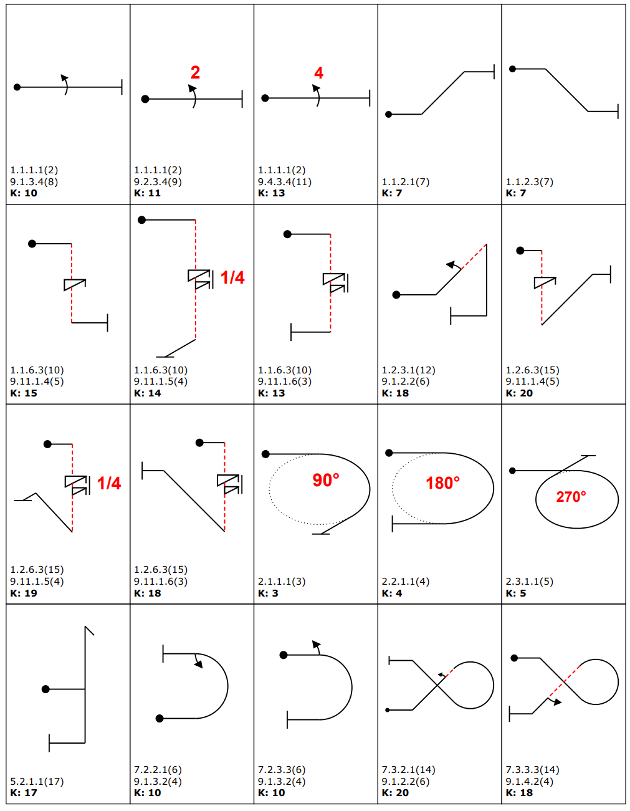

Sports Class (Power) - continued
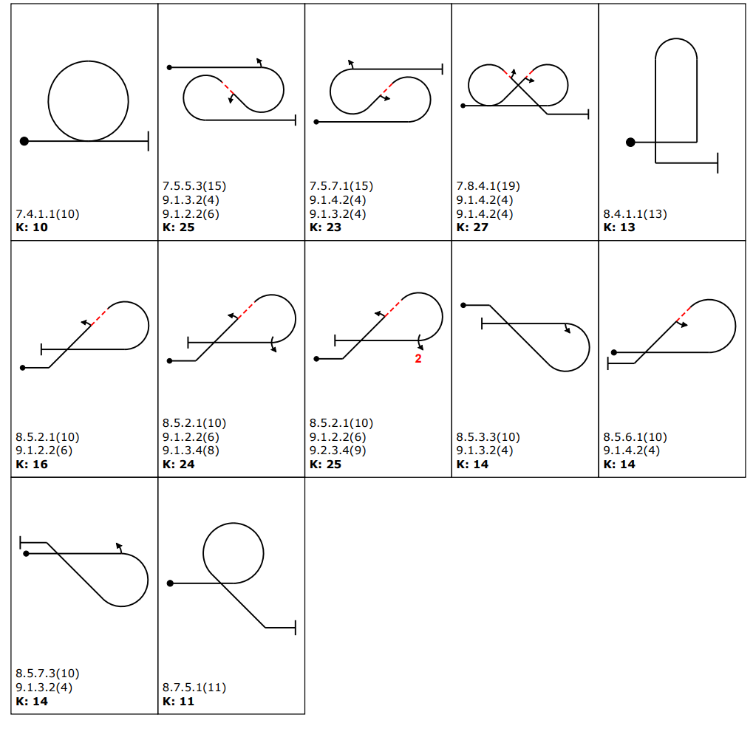

Intermediate Class (Power)
    - Figures prescribed in CIVA Rules, the figures shown below and figures permitted at Sports class are permitted for construction of Unknown sequences. Note that CIVA requires between 1 and 4 additional “linking figures” to be used in sequence construction. Linking figures are selected by the person designing the sequence and are intended to be simple figures that enable the designer to make the sequence flyable.
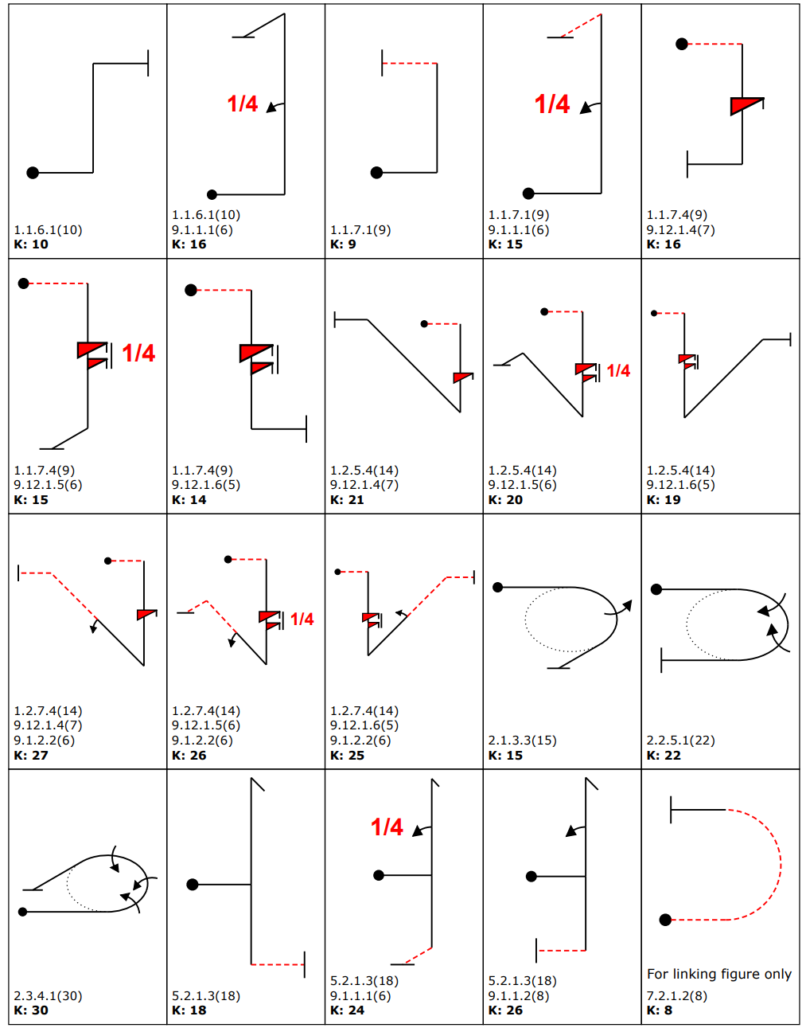

Intermediate Class (Power) - continued
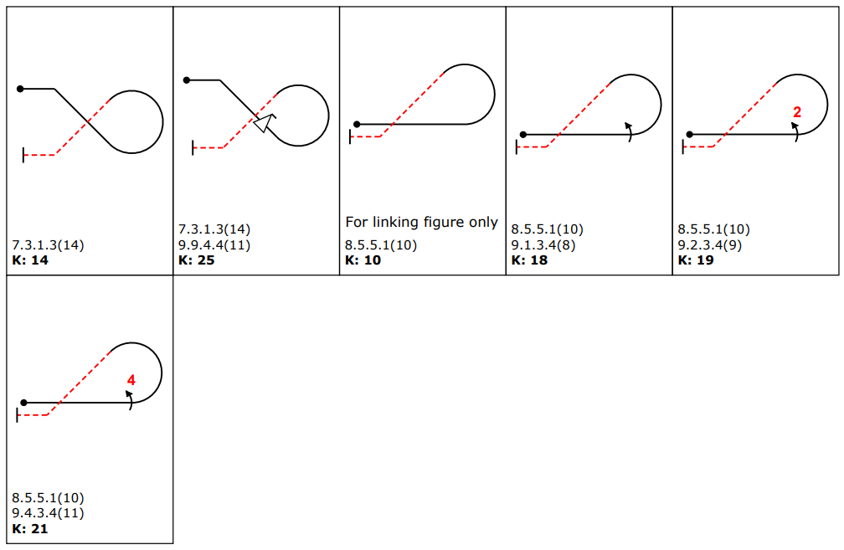

Advanced Class (Power)
    - Figures prescribed in CIVA Rules, the figures shown below and figures permitted at lower classes are permitted for construction of Unknown sequences.

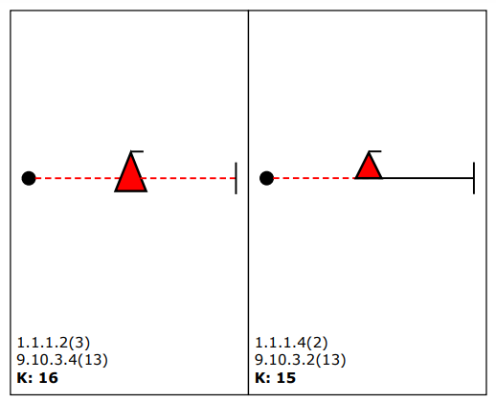

Unlimited Class (Power)
    - Figures prescribed in CIVA Rules, plus the figures permitted at lower classes are permitted for construction of Unknown sequences.

Judging & Scoring

Judges
    - There will be a minimum of three judges. The CJ may be a non-scoring judge so long as there are at least three other scoring judges.

    - The judges will be helped by assistants, timekeepers and other officials as deemed necessary by the CJ. Where possible, the judges should be positioned in the judging area not less than 15 metres apart.

Scoring of Contest Programmes
    - Marking and scoring of programmes will follow CIVA rules, subject to any differences noted in this document.

Positioning
    - Positioning is scored in one of two ways: mechanically, by means of a tracking device; or by the individual judges. Judges should follow CIVA guidance when assigning positioning scores.

Positioning Difficulty Factors
Class | Positioning Difficulty (K Factor)
Club | 10
Sports | 15
Intermediate | 30
Advanced | 30
Unlimited | 40

Criteria for Judging the Freestyle Programme
    - Judging Criteria for the Freestyle programme are specific to British Aerobatics contests and differ to CIVA rules.

    - The judge will assess each Freestyle flight considering the following criteria and will award an overall mark between 0 and 10 points depending on how well the flight demonstrated the following criteria.

- Programme design and artistic rendition
• Comprehensive variety of freestyle and classical manoeuvring with high dynamic range
• Combinations of traditional elements and fresh or original manoeuvres
• Interesting diversity of flight-paths not restricted to classical main / cross box axes
• Avoidance of dull or boring periods that might indicate lack of planning
• Effective and sympathetic use of smoke and / or any accompanying audio track

- Integration of flight paths and attitudes
• Smooth and flowing execution with good control
• Consecutive periods with different characteristics harmoniously linked
• Use of many vectors and curving flight paths to present individual features

- Technical excellence and dynamic range
• Clarity of intentions and accuracy of presentation through all flight regimes
• Exploration of fast and slow speed regimes, forward and backward flight
• Freedom from obvious corrections, uncontrolled or unplanned departures

- Aerodynamic controls and propeller-driven elements
• Good use of full range of positive and negative angles of attack
• Accurate slow, fast and hesitation rotations, use of yaw, pitch and roll axes
• Wide variety of positive and negative flicks and unusual rotations
• Interesting range of propeller-driven gyroscopic elements and tumbling

- Use of the performance zone and allowed time to maximum advantage
• Imaginative and balanced use of the width, height and depth of the performance area
• High and wide elements not too close, low elements not too distant to assess
• Manoeuvres and transitions positioned and orientated for best impact
• Imperceptible handling of wind effects
• Good use of the available time to demonstrate a wide range of manoeuvres

    - Once all pilots have flown, each judge will review their own scores for all flights and will then rank the pilots in order from best to worst. This rank order will be aggregated across all judges to calculate an average rank for each competitor. The average rank will determine the results. In the event of a tie in the average ranks the original 10 point ratings will be used to separate the pilots. If results are still tied the CJ will convene a meeting of the judging panel and a vote will be taken to decide which flight was best, with the CJ having the casting vote in the event of a tie.

Penalties

Application of Penalties
      - A contestant will only be penalised or excluded on a simple majority decision of the panel of judges, except regarding matters of safety when the CD or CJ can decide to exclude a contestant from a programme or the contest. Where there is no majority among the panel of judges, the CJ will have the casting vote. Penalty tariffs are shown in the Quick Reference section at the end of this document.

Violation of Safety Figure and Optional Figure Procedures
      - Failure to fly prescribed safety figures will result in a training violation penalty. Flying figures other than those permitted as warm up or practice figures will result in an insertion penalty and a training violation penalty.

Height Penalties
      - There is no upper height limit, although the individual marks for positioning may be adversely affected by excessive height. A low penalty shall be applied every time a competitor breaks the lower height limit during a sequence. It is possible to break the lower height limit more than once in a single figure. A low penalty will also be given for each figure flown completely below the lower height limit.

Time Penalties
      - Time penalties will only be given in Intermediate, Advanced and Unlimited classes in accordance with CIVA rules.

Dangerous Flying
      - In addition to penalties for infringement of the height regulations, any flying deemed by the CD or CJ to be dangerous will result in disqualification from the programme during which the incident occurred and possible exclusion from the contest as deemed appropriate by the CD and CJ. Dangerous flying applies to any part of a flight conducted during the contest, including take off and landing. The CD should inform the MT of the incident.

Break in the Sequence or Insertion of a Figure
      - A break in the sequence to change direction by more than 90 degrees or to regain height other than for reasons of weather previously agreed by the CJ will not be penalised at Club or Sports classes.

      - A break in the sequence to change direction by more than 90 degrees or to regain height other than for reasons of weather previously agreed by the CJ will be penalised at Intermediate and higher classes.

      - An insertion penalty will be applied to any figure that is added to the order of the programme at all classes.

      - If a pilot is awarded a mark of zero for a figure, takes a break and then repeats the previously zeroed figure, this repetition will not be treated as an insertion.

      - If a pilot adds a figure into a sequence that is not shown on the sequence card, the added figure replaces the figure shown at that point in the sequence on the diagram, which is zeroed.

For example, if the pilot should have flown a stall turn, loop, and humpty, but performs a stall turn, slow roll, loop and humpty, then the stall turn is marked, the slow roll is counted as the loop so is zeroed, the loop has already been zeroed so is not judged and the humpty can be graded as usual. In this case no insertion penalty is incurred. If the same pilot had flown a stall turn, a half Cuban, realised that they were now in the wrong direction, so inserted a 180 degree turn to get the right way (without breaking) then flew the loop and the humpty, the stall turn would be marked, the loop zeroed (because the pilot flew a half Cuban instead), the insertion of the 180 degree turn would be penalised (because the pilot gained an advantage from using the 180 turn instead of taking a break), the loop is not marked (its treated as a repeated previously zeroed figure) and the humpty is marked.

      - Insertion of figures will be penalised at all classes.

Violations of Signalling Procedures
      - A penalty will be given in case of violation of signalling procedures in all categories.

Directionality
      - Any figure with both entry and exit lines aligned on the secondary axis must be flown with the exit direction relative to the entry direction as drawn on the sequence Forms B and C (respectively R and L) that is, in the same or the opposite direction, otherwise the figure will be marked Hard Zero (see illustration below).
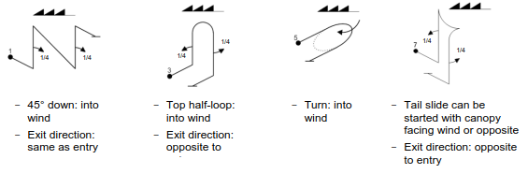

Box Out Penalties
      - If an electronic tracking system is used for recording infringements of the performance zone, box out penalties will be applied as described in CIVA Rules.

Calculation of Overall Scores
    - In all classes the total of all judges' scores will be computed either using a statistical analysis system approved by the MT or using straight averaging of figure grades. The analysis method will be decided by the CJ.

    - Score sheets will be published (either on paper or via the web) as quickly as possible once each pilot’s results have been calculated. Pilots have 1 hour from publication to check their scores and protest any anomalies.

Pilot Proficiency System

Aim
    - The primary aim of the Proficiency System is to ensure safety at British Aerobatics contests. The secondary aim is to provide pilots with recognition of their progress in aerobatics. Operation of the Pilot Proficiency Scheme is described in detail in the Operations Manual. The Flight Assessment form can be found on the British Aerobatics website.

Flight Evaluators
    - Flight Evaluators (FE) are British Aerobatics members with an extensive experience of competition aerobatics, who are authorised by the British Aerobatics Directors to act on behalf of British Aerobatics to implement the Pilot Proficiency System. They must fulfil the following requirements at the time the evaluation takes place:

- Be a current member of British Aerobatics
- Be a current FI/CRI with aerobatic privileges
- Have flown in competitions at least one class above the class being evaluated
- For Unlimited and Freestyle classes/signoff, have at least 10 years experience of flying at that level with a proven track record of ground coaching at Unlimited class for International events.
- Be current on modern aerobatic aircraft, including understanding what is happening inside the cockpit on a Flight Evaluation and the impact this has on flight safety.
- Must attend the annual Flight Evaluator briefing run by British Aerobatics, or have a personal briefing from the Chairman.

    - A current list of Flight Evaluators, their locations and contact details is published on the British Aerobatics website and reviewed annually by the British Aerobatics Directors.

    - A Flight Evaluator’s authority may be suspended or withdrawn at any time by the British Aerobatics Directors.

Operation
    - The Proficiency System applies to all competing pilots.

    - All new pilots must undertake an evaluation flight, have the completed form approved by the Chairman and must upload the approved Flight Evaluation Form as a credential on the British Aerobatics contest administration web platform before the closing date of the first contest they wish to enter. As part of this sign-off they will be required to provide documented evidence that adequate aerobatic training has been completed.

Evaluation Flights
    - All Flight Evaluations must be conducted solo with the Flight Evaluator observing from the ground and in contact by radio.

    - The minimum height for an evaluation flight must be agreed in advance and must be no lower than that specified in these Rules for the class of contest concerned.

    - The pilot must fly the Known sequence for the class and year in question, plus any additional figures specified by the Flight Evaluator. These additional figures will normally be flown individually and will be chosen from those which may be included in Unknown sequences in the relevant class. It is particularly important that the Flight Evaluator ensures that the pilot demonstrates the ability to recover from the full range of intentional spins introduced in the class.

    - The Flight Evaluator will discuss with the pilot their experience of the planning required for contest flights. Detailed guidance about how the Flight Evaluator should conduct the evaluation is provided in the British Aerobatics Operations Manual, including a Flight Evaluator Checklist.

    - The Flight Evaluator must complete a Flight Evaluation Form on which is recorded the outcome of the assessment (pass or fail) and, if applicable, reasons why the applicant failed.

    - If the applicant passes the assessment, the Chairman will review the completed Flight Evaluation Form to give final approval before the pilot competes at a contest.

    - If the applicant fails the assessment, they must be re-evaluated by the same Flight Evaluator after they have undertaken appropriate remedial training. If this will present logistical difficulties, then the Directors shall be consulted in all instances before any further Flight Evaluation takes place.

Standards
    - To be eligible for proficiency sign-off, the pilot must fly the sequence and additional figures in a safe and confident manner. The pilot must also demonstrate an appropriate degree of skill in positioning the sequence in the prevailing wind conditions.

    - Small errors of geometry, nor even hard zeroes for turning the wrong way, will not be used as reasons for denying the proficiency sign-off. The Flight Evaluator must be convinced, however, that the pilot is always in proper control of the aeroplane and has sufficient spare mental capacity to cope with the stress of contest flying, especially during Unknown sequences.

Promotion to a Higher Class
    - Each pilot must again undertake a flight evaluation and must submit a completed, successful evaluation form by the entry closing date of the contest entered in a higher class.

Lapsed Proficiency sign-off
    - If a pilot does not compete for a period of 24 months, their proficiency sign-off is considered to have lapsed. Before they can compete again in a previously endorsed class, they must obtain a new evaluation report from a Flight Evaluator.

Revocation of Proficiency sign-off
    - In the event that a pilot flies at a contest to a standard considered by the CD or the CJ to be below that expected at a contest for that class, the CD and CJ will discuss the incident and forward details to the British Aerobatics Directors. The Directors may then revoke the pilot’s proficiency sign-off for that class. In this case, the pilot will be advised to gain more contest experience in a lower class, or to undertake more training outside the contest arena, before re-submitting themselves to a different Flight Evaluator for proficiency sign-off in the previously unsafe class.

    - Following revocation of their proficiency sign-off by the Directors, a pilot may make an appeal, in writing, to the Chairman who will consult the Directors and the MT to discuss the case and make a final judgement.

    - In the event of disputes about the outcome of a Flight Evaluation, the Chairman’s decision will be final.

Administrative & Supplementary Rules

Interpretation of Rules and Procedures
    - The interpretation of all rules and regulations at a contest or event is ultimately the responsibility of the CD or Event Director, after consultation with the Chief Judge and, if appropriate, the Contest Jury.

Protests
    - All protests must be made to the CD within one hour of the occurrence and must be accompanied by a protest fee equivalent to half the entry fee. The CD or Contest Jury will consider the protest. If the protest is upheld, then the protest fee will be returned.

Supplementary Rules and Regulations
    - It may be necessary to issue additional, complementary, or temporary rules and regulations from time to time if in the opinion of the MT these are required on the grounds of safety, to meet local requirements or are for the improvement of the aerobatic contest.

Expenses
    - All participants are responsible for paying charges relating to their aircraft levied by the operators of the host airfield. British Aerobatics has no power to act as an intermediary in such matters.

    - British Aerobatics cannot be held liable for any costs incurred by pilots flying at contests for any reason, including weather delays or instructions by the CJ or CD that impacted a participant’s flying activities.

    - If a participant has unpaid debts to either British Aerobatics or operators of host airfields, British Aerobatics may suspend the pilot’s membership until the debt has been paid.

    - Officials may claim for accommodation costs they personally incurred for each scheduled flying day and preparation days, other than the last contest day, subject to the spending limits and requirements stated on the Expenses Claim Form published on the British Aerobatics website.

    - Composite accommodation and mileage claims are not permitted. The primary purpose of British Aerobatics expenses policy is to reimburse accommodation costs. Mileage claims are designed for officials who choose to commute instead.

    - Very occasionally, a contest may be "weathered off" at the discretion of the CD. Officials should seek to book accommodation with a flexible refund policy. Where this is not possible, non-refundable accommodation costs will be met subject to the relevant spending limits.

    - Officials in the following categories are eligible to claim expenses:
- The CD/ED and CJ
- The Judges and Judges’ Assistants
- The Registrar/Scorer
- The Video Operator
- The Starter/Flight Director
- Other officials or volunteers as approved by the CD

    - Claims must be made on the Claim Form, which can be found on the British Aerobatics website, submitted in arrears to the Treasurer. All claims must be supported by valid invoices or receipts.

    - Other expenses related to British Aerobatics activity may be refunded subject to prior approval by the Treasurer or two members of the MT.

Membership
    - Membership of British Aerobatics will be deemed to be valid when the requested member information is provided and the appropriate fee has been paid via the contest administration web platform.

    - Membership of British Aerobatics will be deemed to have lapsed when the published membership fee remains unpaid 30 days after a notification that the fee is due. Fees are normally due on the 1st March in each year.

Banned or Inappropriate Substances
    - British Aerobatics is resolved to ensure that competitors neither seek nor gain any advantage by using banned or inappropriate substances, and that all pilots thus can compete in a fair and open contest.

    - Competitors must comply with the UK Anti-Doping Rules published by the UKAD (or its successor), as amended from time to time.

    - All competitors may be subject to in-competition testing. Competitors selected for a ‘Registered Testing Pool’ will be subject to out-of-competition testing and will have to provide ‘whereabouts information’.

    - For further information on anti-doping, follow these links:

Detailed information and guidance on all anti-doping and WADA matters and application for Therapeutic Use Exemptions (TUE's) are given by the FAI web page at https://www.fai.org/anti-doping. Specific drugs that a competitor may take for medical reasons can be checked here: http://www.globaldro.com/uk-en/search/default.aspx

Procedure for British Team Selection

Aim and Representation Rights
    - The aim of these procedures is to select competitive pilots and support officials, up to the maximum allowed, for the World, European or Continental Championships in Intermediate, Advanced and Unlimited classes.

    - A pilot or contest official can only represent Great Britain in a FAI Championship if nominated by the MT and approved by the Directors.

Performance Evidence
    - British Aerobatics will schedule contests and a National Championship in each calendar year.
Performance in all contests at the relevant class during the current season will be considered during the selection process. A pilot is not normally eligible to be considered for selection unless they consistently score at least 70% of possible points in UK contest sequences flown at the relevant level.
Failing an ability to participate and qualify for Team selection via domestic contests, the Selection Panel, at their sole discretion, may review and accept alternative evidence of satisfactory performance, including performance in previous years, performance at training camps and/or performance at relevant contests run in other countries, e.g. Open Contests and International Contests.
Unlimited results may be used for Advanced Team selection where appropriate.
Advanced results may be used for Intermediate Team selection where appropriate.

Selection Panel
    - The MT will appoint a Selection Panel of no less than 2 and no more than 5 persons. These persons may be from the MT, Directors or co-opted individuals who require first-hand knowledge of the demands of international championships.

Pilot Application and Selection.
    - A pilot wishing to be considered for Team Selection should notify the MT.

    - The Selection Panel shall select Team pilots. Pilots may be invited to join a pool of applicants who will train together ahead of international contests. This pool may include unselected pilots that are being developed for future international contests.

    - If more pilots wish to attend an International Contest than are permitted by CIVA, the Selection Panel has the final decision about which pilots should attend.

    - The aim of the selection process is to identify pilots who have potential to excel at international contests, build a stable squad and support the continued development of individual pilots and the team. Therefore, purely quantitative results and technical (Tech) flying skills will not be the only information used to select. Pilots will also be assessed for non-technical (NoTech) skills in line with current aerospace standards to ensure a cohesive and collaborative Team outcome.

    - The Selection Panel is not obliged to fill all vacant team positions.

    - A pilot shall confirm acceptance or rejection of a Team place to the Selection Panel within two weeks of an offer being made. If acceptance is not received by this time, the place can be offered to another candidate.

    - The foregoing criteria also apply to the selection of a reserve pilot who may be offered a team place in the event of the withdrawal of a higher-placed pilot.

    - In the event that a selected pilot relinquishes their place, only the nominated reserve will automatically be eligible to take that place and the Selection Panel may select a new reserve pilot.

    - The Selection Panel will establish an alternative selection and offer the place accordingly if the nominated reserve declines the place.

    - Persons selected must agree to act as an integral part of the Team and to participate fully as Team members before and during the relevant championship, including participation at training camps and media events.

Other Team Positions
    - The Selection Panel will also consider nominations for other official Team positions. Persons selected are expected to act as an integral part of the Team and to participate fully as Team members before and during the relevant championship.

Conduct of Team Members
    - The conduct of Team Members must always be beyond reproach.

    - Any Team Member whose actions may harm the international reputation of British Aerobatics shall be subject to disciplinary action by the MT. This action may include suspension of selection for British Teams, revocation of an International Sporting Licence if held and removal from CIVA officials lists.

Code of Conduct

Background
    - Every year British Aerobatics organises events when flying takes place at host airfields. The intention of such events is that they are beneficial, not only to British Aerobatics and its members, but also to the groups and individuals who normally operate from the airfields in question.

    - The arrival at the host airfield of many visiting aircraft, pilots, officials, and supporters can be disruptive, and a long series of contest flights throughout the day can easily spoil the operating routine at the host airfield. There is therefore a real need for understanding and co-operation on all sides if the aims of the event are to be met.

    - The aim of this code of conduct is to provide a framework within which contest organisers, competing pilots and the authorities at host airfields can work together to ensure a mutually beneficial relationship.

The Purpose Of Contests
    - The main purposes of contests are:

- To provide pilots with an opportunity to learn more about aerobatics in general
- To encourage novice aerobatic pilots to experience the benefits of friendly competition via the Get into Aeros events, Club events and special events
- To enable competing pilots to pit their aerobatic skills one against the other in safe, impartial, and open contest
- To provide groups and individuals at host airfields with an interesting and beneficial annual event
- To further the sport of aerobatics at host airfields

General Principles
    - The prime consideration at aerobatic contests and events shall always be safety.

    - Once safety has been established, sportsmanship, good manners and camaraderie should always prevail.

    - Discipline of competing pilots and other British Aerobatics members at a contest shall be the responsibility of the CD. Competitors and participants must respect the authority of the CD. Upholding the spirit of the rules, practising good airmanship and adopting a safety first ethos is the responsibility of all participants - pilots and officials alike.

    - Individuals must exercise self-discipline to ensure they exhibit appropriate behaviour that is expected of members of British Aerobatics. The CD has the right to take action to enforce adherence to operating procedures, the rules and uphold the spirit of the Code of Conduct.

    - Promotion of a safety culture is not the sole responsibility of the CD. It is a shared endeavour and all participants have a responsibility to act safely, respectfully and in a spirit of mutual support and cooperation.

    - Any protests about the operation of the contest must be made in accordance with the procedure given in the General Rules.

    - Persistent dissent shown towards the CD or other contest officials shall result in a competitor being disqualified from a contest.

    - This code is complementary to the General Rules for the Conduct of Aerobatic Contests published by British Aerobatics.

The Conduct of Contest Officials
    - Prior to the issue of contest briefing papers, the CD shall establish close liaison with appropriate persons at the host airfield to ensure local requirements are included in published material.

    - Copies of contest briefing papers should always be sent to the host airfield at the time of general circulation.

    - To ensure clear, unambiguous communication, a single point of contact shall be established between British Aerobatics and the host airfield. Usually this will be the CD.

    - The CD will agree special operational procedures with the responsible authority at the host airfield to ensure that local flying may continue with as little disruption as possible.

    - The CD will agree the location of the aerobatic performance zone with the responsible authority at the host airfield in accordance with the procedure described in the British Aerobatics Risk Assessment and Safety Analysis document and the Operations Manual.

    - The CD will also review the major incident plan with the host airfield to ensure that emergency response procedures and the responsibilities of British Aerobatics and host airfield staff are defined clearly ahead of the contest.

    - At all contest briefings, the appropriate local official shall be invited to address competing pilots on local procedures and sensitivities.

    - When considered appropriate, the CD will agree in advance of the contest, any fees, or other costs to be paid by British Aerobatics or its members to the host airfield authorities.

    - Where appropriate, the CD will make arrangements for the briefing of the media and the public as to the conduct and progress of the contest.

    - After the contest is complete, the CD will review the conduct of the event with host airfield officials.

The Conduct of Competing Pilots
    - Competing pilots shall always display exemplary airmanship. Attendance at, or participation in a British Aerobatics contest in any class does not, under any circumstances, grant the pilot exemption from any aspect or clause of the Air Navigation Order, the Rules of the Air Regulations nor any other statutory instrument, nor from any local regulations.

    - Pilots should remember that the aim of contests is to promote friendly rivalry and good sportsmanship.

    - Arrival at and departure from the host airfield shall be in the normal manner prescribed for visiting aircraft.

    - Aerobatic practice flights within 10 nm of the airfield are generally discouraged during the week leading up to the contest to avoid causing noise nuisance.

    - Competing pilots shall always understand that they are guests of the host airfield and act accordingly.

    - When not actively preparing for a contest flight, pilots shall endeavour to encourage and inform local individuals and groups about the practice of contest aerobatics.

    - Pilots shall ensure that all outstanding fuel bills, landing fees etc are paid before departure. Contravention of this rule may lead to exclusion from future contests.

The Conduct of Host Airfield Officials
    - The host airfield authorities shall nominate one individual to be the single point of contact with British Aerobatics.

    - The hosting authority will ensure that all relevant local conditions and operating practices are brought to the attention of visiting pilots in the Main Briefing for each contest.

    - The host airfield authority has responsibility for control of the public and provision of appropriate facilities to host spectators, considering the requirements of CAP 403 as being indicative of best practice in these respects.

    - The host airfield will make a parking/hangarage area available for competing aeroplanes and, where possible, restrict access to this area by the public.

Personal Safety for Pilots
    - The Code of Conduct emphasises the prime importance of safety at aerobatic contests. British Aerobatics Directors, MT, contest officials, volunteers, competitors and all participants are charged with monitoring and always maintaining safety standards.

    - Participating pilots are also urged to always consider their personal safety as paramount and should pay particular attention to their choice of personal safety equipment and protective clothing. In particular, the wearing of a protective helmet has proven to be of prime survival value in aircraft accidents. Pilots should also consider the installation of an approved pilot parachute system, where permitted for their aircraft.

Other Events
    - All the provisions of the Code of Conduct shall apply to participants in Special Events, Training Events and meetings and social gatherings organised by British Aerobatics.

Procedure in the Event of a Serious Accident or Casualty
    - Participants should report the occurrence of an incident to a contest official, to the local staff responsible for managing air traffic, or to another member of the airfield staff, whichever is quicker, who must immediately contact the local air traffic management personnel to inform them of the incident and request appropriate incident response (e.g. fire, rescue and medical services).

    - In the event of a serious accident or casualty at a British Aerobatics contest or event, the host airfield’s emergency response plan will be activated.

    - British Aerobatics officials will support the host airfield staff to provide an appropriate response to the incident.

    - Once the alarm has been raised, if a victim involved in the incident needs help and the rescue team has not arrived on scene, participants must consider the danger they and other participants may be exposed to if a rescue is attempted. The professional incident response teams will have the training and equipment needed to respond to the incident appropriately and in most cases, it is best to let the professional team handle the situation.

    - A participant must not attempt to move a victim unless asked to do so by the rescue team, under their supervision, except if the victim is in imminent mortal danger and the rescue team has not arrived on scene. However, participants must be aware that any intervention in these circumstances could place both the victim and the participant in grave danger.

    - In circumstances where it has been established that no further assistance can be given to the pilot (or any other people involved in the incident) and that a fatal incident has occurred, the accident site must be secured, and measures implemented to ensure that the area remains undisturbed until the Police and Air Accident Investigators arrive on scene. An effort should be made to shield the accident site from view if possible.

    - Witnesses to the accident should be requested by the CD or their deputy to remain on-site until the police have said they can leave.

    - Participants should not watch video footage of the incident until given permission to do so by the police or AAIB but should hand any photographs or video footage of the incident to the CD. No photos or video footage of the incident should be made public.

    - When the contest participants next meet (morning briefing, or a special briefing), the CD should inform them of the incident's basic facts, of the action taken and decisions made regarding the future continuation of the contest.

    - There will almost certainly be media and public enquiries or presence at the event site and/or the site of any major accident (which may be off the event site). Opinions, assumptions, and the names of individuals involved should not be passed to the media. A properly constructed announcement will be released to the public and media by the CD on behalf of British Aerobatics.

Supplementary Rules for Glider Contests

Applicability
    - This section described rules or operating procedures that are different for glider contests.

Pilot Qualification
    - Competing glider pilots must hold an appropriate aerobatics certificate recognised by the BGA. Instructors must hold an appropriate aerobatics instructor qualification recognised by the BGA.

    - Pilots require a current Part-SFCL sailplane license (SPL) with basic aerobatic privileges to fly at Club class and Advanced privileges to fly at Sports or higher levels.

Aircraft Qualification
    - All competing aircraft should employ a duplex harness system or a single harness and parachute.

    - All aircraft (including tug) must be equipped with a properly functioning air-band transceiver radio able to communicate on 8.33kHz VHF channels.

    - All aircraft (including tug) must carry third-party liability insurance meeting the requirements of Article 7 of Regulation (EC) No. 785/2004, or the required Ministry of Defence minimum if different when the contest takes place at a Ministry of Defence airfield.

    - The insurance cover must clearly state that British Aerobatic Association Limited is noted as an additional insured and that the insurance does not exclude aerobatic contests.

    - Rules about fuel and oil systems are not relevant to unpowered gliders.

Contest Operation
    - Familiarisation and Practice Flights at the contest site are permitted subject to prior approval by the CD and Airfield Operator.

    - Fixed Known sequences will be flown at all classes. In Club and Sports Classes there may be more than one Known sequence per Class.

    - One or more Fixed Unknown sequences may be flown at Sports and higher classes.

    - The Freestyle programme is not applicable to glider contests.

Airborne Procedures
    - The safety principles described in Airborne Procedures for Powered Aircraft will apply to Glider contests with the following differences:

    - To avoid radio frequency changes whilst on tow, the glider pilot should select the safety frequency before take-off. Routine box clearance messages will be exchanged between the CJ and the tug pilot, and monitored by the Flight Director, on the airfield frequency.

    - Once the glider/tug combination is on final approach to the box, any urgent calls from the CJ to the glider pilot will be made on the safety frequency. The glider pilot must acknowledge receipt and understanding of these calls by responding appropriately to the CJ. After release, the tug pilot will vacate the performance area expeditiously and continue in accordance with local procedures.

    - After completion of the sequence, the glider pilot should call “(callsign) box vacated” on the safety frequency. This will inform the next competitor of the situation. Thereafter, the glider pilot should comply with procedures briefed by the host airfield.

    - Notwithstanding any radio calls exchanged with a ground station, the responsibility for seeing and avoiding other air traffic rests entirely with the tug and glider pilots at all times.

Height Limitations
    - Height limits are defined in the table below. If the cloudbase is below 3,500ft, a split programme can be flown using a launch height of 2,500 feet.

 | Club | Sports | Intermediate | Advanced | Unlimited
Upper | 4000 ft | 4000 ft | 4000 ft | 4000 ft | 4000 ft
Upper Split | 2500 ft | 2500 ft | 2500 ft | 2500 ft | 2500 ft
Lower | 1500 ft | 1000 ft | 1000 ft | 700 ft | 700 ft
Exclusion | 1000 ft | 700 ft | 700 ft | 500 ft | 500 ft

    - A glider pilot will be excluded from the programme if they gain height through intentional use of thermals.

    - No aerobatic figures are permitted prior to starting the competition sequence. After completion of the sequence the glider must be landed expeditiously without performing further figures.

Penalties
    - Omission of the wing-rocks at the start or finish of a programme will be penalised for Intermediate, Advanced and Unlimited. The pilot shall not rock the aircraft’s wings before or after a break in the programme. Once a sequence has started wing rocking indicates the conclusion of the programme.

    - If a pilot is compelled to change their direction after a mistake or after an abandoned figure to resume the predetermined direction and has already received a Hard Zero mark for that figure, no penalty points for an insertion will be subtracted. This correction of direction or orientation must not be more than a heading change of 180 degrees or attitude change of more than one half roll or half loop.

    - A low penalty shall be applied every time a competitor breaks the lower height limit during a sequence. It is possible to break the lower height limit more than once in a single figure. A low penalty will also be given for each figure flown completely below the lower height limit. Flying figures below the exclusion height will result in a pilot's disqualification from that programme.

    - There are no penalties for a break in the sequence during any programme in any class.

    - Training violation and missed slot penalties are not relevant to Glider contests.

Sequence Specifications

 | Club | Sports | Intermediate | Advanced | Unlimited
Known Max K | 55K | 135K | 140K | 175K | 230K
Unknown Max K | N/A | 135K | 140K | 175K | 230K
Base aircraft | K21 | K21 | K21 | Fox | Fox

    - If CIVA specified figures are used to build a Known sequence, the maximum K can be adjusted by 3K from the linking figures as described in CIVA regulations. If pilot nominated figures are to be used to build Unknown sequences individual maximum K figure limits may be set by British Aerobatics. Permitted figures for Unknowns will follow CIVA specifications for Advanced and Unlimited subject to any variations described in these rules.

Permitted Unknown Figures - Glider

Sports Class (Glider)
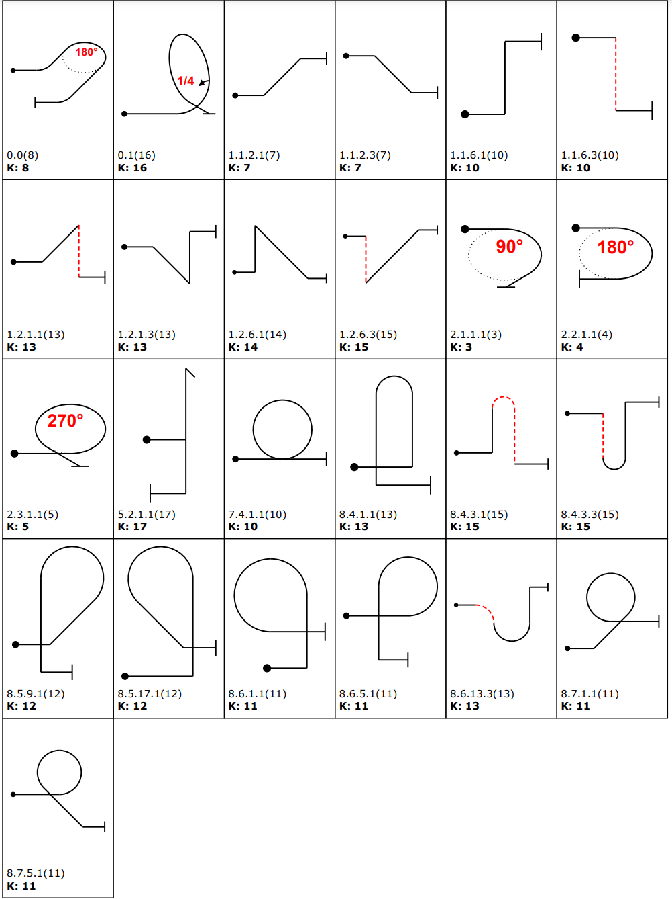

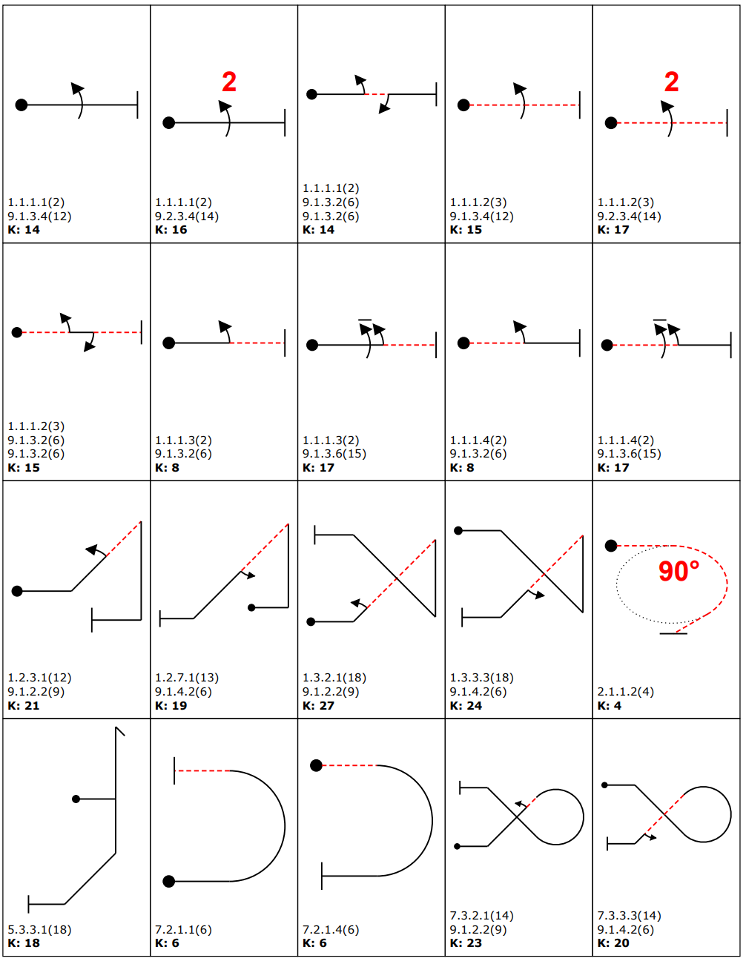
Intermediate Class (Glider)

Intermediate Class (Glider - continued)
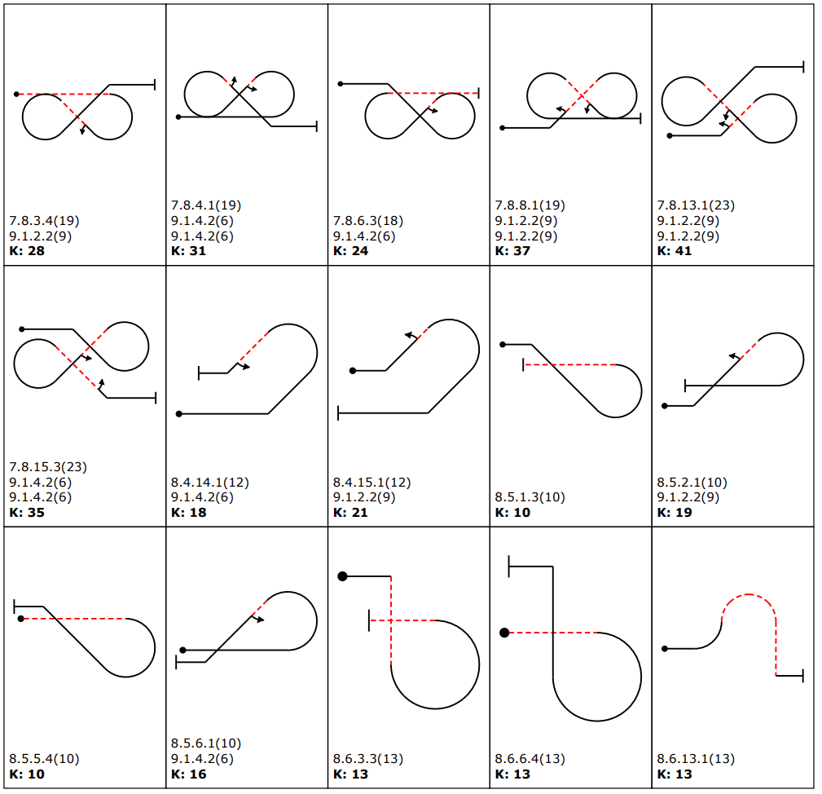

Advanced Class (Glider)
      - All figures from the Aresti System (Condensed - Glider) catalogue may be flown in the Advanced Class, except for the following restrictions:

- Loops and Part-Loops
  - No full negative loops.
  - No high-speed negative part-loops of more than 45° (max. 1/8 loops)
- Family 2
  - No rolling turns, except Cat. No. 2.1.3.1 which is optional in the Free Programme.
- Family 9
  - No rolls vertically up.
  - No more than 1/4 roll vertically down.
  - No flick rolls, positive or negative.
  - No inverted spins.

Unlimited Class (Glider)
      - All figures from the Aresit System (Condensed - Glider) catalogue may be flown in the Unlimited class.

QUICK REFERENCE: POWER

Penalties & Positioning
 | Club | Sports | Intermediate | Advanced | Unlimited
Too Low | 200 | 200 | 200 | 200 | 250
Interruption (break) | 0 | 0 | 50 | 80 | 100
Insertion | 50 | 50 | 50 | 80 | 100
Missed Slot | 100 | 100 | 200 | 200 | 250
Out of box | 20 | 20 | 20 | 20 | 30
Training Violation | 200 | 200 | 200 | 200 | 250
Other | 0 | 0 | 30 | 30 | 30
Time Penalty | - | - | - | - | 10/sec Freestyle
Positioning | 10 | 15 | 30 | 30 | 40

Height Limits
 | Club | Sports | Intermediate | Advanced | Unlimited
Upper | None | None | None 3 | None 3 | None 3
Lower | 1500 ft | 1000 ft | 1000 ft 1 | 660 ft | 500 ft 2
Exclusion | 1300 ft | 800 ft | 800 ft 1 | 500 ft 2 | 500 ft 2
Height limitations are taken from CIVA Sporting Code Section 6-1 except as modified by:
1 Intermediate class heights for British Contests are set higher than CIVA rules
2 Flight below 150m (500 ft) can only be allowed with an exemption from the CAA to the low flying regulations SERA.5005 (f)
3 Upper height limits will not be enforced at British contests

Weather Limits
 | FREE BREAK weather limits
 | Club | Sports | Intermediate | Advanced | Unlimited
Cloudbase | any number of unpenalised breaks may be taken at the pilot's discretion |  | 4100 ft | 3800 ft | 3500 ft
Headwind |  |  | > 24 kts | > 24 kts | > 24 kts
Crosswind |  |  | > 16 kts | > 16 kts | > 16 kts
 | Cloudbase and visibility MINIMA below which no flying will happen
Min Cloudbase | 3000 ft | 3000 ft | 3000 ft | 3000 ft | 3000 ft
Min Visibility at 3000 ft | 5km | 5km | 5km | 5km | 5km
All heights are above ground level

QUICK REFERENCE: GLIDER

Penalties & Positioning
 | Club | Sports | Intermediate | Advanced | Unlimited
Too Low | 70 | 70 | 70 | 70 | 70
Interruption | 0 | 0 | 0 | 0 | 0
Insertion | 20 | 20 | 20 | 70 | 70
Missed Slot | - | - | - | - | -
Out of box | 2 Points per Second Out Of Box
Training Violation | - | - | - | - | -
Other (e.g. wrong signalling) | - | - | 35 | 35 | 35
Positioning | 10 | 15 | 15 | 20 | 25

Height Limits
 | Club | Sports | Intermediate | Advanced | Unlimited
Upper | 4000 ft | 4000 ft | 4000 ft | 4000 ft | 4000 ft
Upper Split | 2500 ft | 2500 ft | 2500 ft | 2500 ft | 2500 ft
Lower | 1500 ft | 1000 ft | 1000 ft | 700 ft | 700 ft
Exclusion | 1000 ft | 700 ft | 700 ft | 500 ft | 500 ft
Min Cloudbase | 2600 ft | 2600 ft | 2600 ft | 2600 ft | 2600 ft

END OF DOCUMENT

